МИНИСТЕРСТВО ОБРАЗОВАНИЯ И НАУКИ
РОССИЙСКОЙ ФЕДЕРАЦИИ

Федеральное государственное автономное образовательное учреждение
высшего образования
«Национальный исследовательский Нижегородский государственный
университет им. Н.И. Лобачевского»

В.П.Савельев
A.В. Oстровский
Г.В.Кузенкова

CONCEPTS OF NATURAL SCIENCES
КОНЦЕПЦИИ СОВРЕМЕННОГО ЕСТЕСТВОЗНАНИЯ

Учебно-методическое пособие

Рекомендовано методической комиссией ИИТММ
для иностранных студентов ННГУ, обучающихся по направлению подготовки
02. 03. 02 “Фундаментальная информатика и информационные технологии”

Нижний Новгород
2018

УДК 51(075.8)
ББК 22
C 12

С 12 Савельев В.П., Островский А.В., Кузенкова Г.В. КОНЦЕПЦИИ СОВРЕМЕННОГО ЕСТЕСТВОЗНАНИЯ: учебно-методическое электронное пособие. – Нижний Новгород: Нижегородский госуниверситет, 2018. – 82 с.

Рецензент: заведующий кафедрой ДУМЧА, д.ф.-м.н.,
профессор Баландин Д.В.

Учебно-методическое пособие разработано в соответствии с требованиями учебной программы по дисциплине «Концепции современного естествознания». Основная идея курса и учебно-методического пособия состоит в том, что для изучения разнообразных явлений и процессов необходимо построить, а затем и изучить математическую модель явления (процесса). Вводятся понятия динамической системы, фазового пространства и фазового портрета, которые затем активно используются для изучения математических моделей.
Учебно-методическое пособие предназначено для иностранных студентов третьего курса, обучающихся по направлению «Фундаментальная информатика и информационные технологии» в Институте информационных технологий, математики и механики ННГУ им. Н.И. Лобачевского.

УДК 51(075.8)
ББК 22

© Нижегородский государственный
университет им. Н.И. Лобачевского, 2018

Contents
- Mathematical model. Dynamical system. Dynamics of population ………………….. 4
  - Mathematical model. Dynamical system……………………………………….4
  - Models of dynamics of biological population…………………………………..6
    - Exponential model…………………………………………………………..6
    - Logistic model………………………………………………………………8
    - Model of disappearing population…………………………………………..9
    - Generalized model of dynamics of population………………………………9
- Water outflow from the vessel. Model of Torricelli and its improvement……………..11
  - The model of Torricelli…………………………………………………………11
  - The improvement of the model of Torricelli……………………………………12
- The system “inflowoutflow”. Simple model of hydropower station…………………17
  - The system “inflowoutflow”………………………………………………….17
  - Siphon…………………………………………………………………………...17
  - Simple model of hydropower station……………………………………………18
- Energetic model of the heart. Soiling a water reservoir with a bay……………………..21
  - Energetic model of the heart…………………………………………………….21
  - Soiling a water reservoir with a bay……………………………………………..23
- Linear oscillator. Phase portraits………………………………………………………...26
- Forced oscillations. APFC. Resonance………………………………………………….32
- Dynamics of coexistence of two populations……………………………………………35
  - Mathematical model of the type “predatorprey”………………………………35
  - A model of competing coexistence of two populations…………………………37
- Some gravitational models………………………………………………………………42
  - A movement of a missile in the cosmic space…………………………………..42
  - A flight of a projectile…………………………………………………………..43
  - A problem of two bodies………………………………………………………..45
- Dynamical models for rational behavior………………………………………………...49
  - Automata models for rational behavior………………………………………….49
  - A problem of pursuit…………………………………………………………….52
- Stochastic dynamical systems with incomes…………………………………………….54
- The choice of optimal strategy…………………………………………………………..57
  - Optimal strategy for a finite process……………………………………………..57
  - Optimal strategy for a infinite process…………………………………………...58
- Optimization. A model of optimal rhythmical production………………………………62
- Perceptron and pattern recognition………………………………………………………70
- Seminars………………………………………………………………………………….75

3
1. Mathematical model. Dynamical system. Dynamics of population
1.1. Mathematical model. Dynamical system
This course of lectures is oriented to give the students some skills not only in solving some exactly stated mathematical problems (these skills they receive well studying such subjects as Mathematical Analysis, Algebra, and so on) but also in stating different problems of nature as strict mathematical problems. As far as I know our graduates are solving some real problems of economy, chemistry, biology, medicine and so on. These problems are usually not formulated as pure mathematical problems. So they have to investigate all aspects of the problem, select its most important properties and construct a corresponding mathematical problem to be studied. To construct a mathematical model (dynamical system) of some process it is necessary to determine properly, what is the state (the description) of the process at any moment of time and how this state will change with increasing of time.
So the concept of dynamical system consists of two following notions: a state $x(t)$ of the system at the moment t and an operator $T(Δt)$, depending upon the parameter $Δt≥0$ in such way that to each state $x(t)$ the operator $T(Δt)$ puts into correspondence the state $x(t+Δt)=T(Δt)x(t)$. Here the operator $T(Δt)$ is supposed to satisfy the property of uniqueness $T({Δt}_{1}+{Δt}_{2})=T({Δt}_{1})T({Δt}_{2})$. It means that the state $x(t+{Δt}_{1}+{Δt}_{2})$ obtained by the application of the operator$T({Δt}_{1}+{Δt}_{2})$, have to be the same that the state obtained by the consistent application of the operators $T({Δt}_{1})$ and $T({Δt}_{2})$ that is
$$x(t+{Δt}_{1})=T({Δt}_{1})x(t),\begin{matrix} & \end{matrix}x(t+{Δt}_{1}+{Δt}_{2})=T({Δt}_{2})x(t+{Δt}_{1})\text{.}$$
So you see that the mathematical model in the form of dynamical system gives us the possibility to predict the further behavior of the process under study. This is the main property of a mathematical description of processes as compared with any others ones. All possible states of a dynamical system form the set that is referred to as the phase space. Applying the operator $T(Δt)$ to all states (points) of the phase space we will receive the phase trajectories. The set of all phase trajectories forms so-called the phase portrait of the dynamical system under study. Let us illustrate these notions considering a free vertical fall of a solid body, having at the moment $t=0$ the height $h_{0}$ above the earth and the vertical velocity $V_{0}$. We are interested in knowing of the height $h(t)$ and the velocity $V(t)$ at the moment $t>0$. Is it possible?

In according to the second law of Newton we can write the following equation
${\text{mh}}^{\text{\} \} = - ital }mg\text{\}\} \{}}$, (1.1)
m being the mass of the body, $h^{\text{\} \} \}\} \{}}$ being its acceleration and $F=−\text{mg}$ being
4
the gravitation force directed opposite the axis h as it is shown in the figure 1.
This equation can be easily solved in according to the initial data:
$h^{'}=−\text{gt}+V_{0}$, (1.2)
$h=−\frac{{\text{gt}}^{2}}{2}+V_{0}t+h_{0}\text{.}$
The admissible types of the plots for the function $h(t)$ are presented in the figure 2.
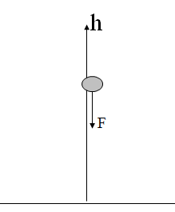
Figure 1. The scheme of the falling body

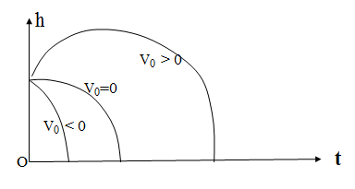
Figure 2. Different types of plots
for the function
Is it possible to predict the process of a free falling body through knowing only its initial state $h_{0}$? Evidently not since the value $V_{0}$ must be known as well. Having this in mind let us take the plane $(h,V)$ where the point M with the coordinates $h(t)$ and $V(t)$ will be moving with increasing time along a curve named trajectory. The equation of this trajectory may be defined: $h^{'}=V,V^{'}=−g$; so $\frac{\text{dh}}{\text{dV}}=−\frac{V}{g}$ and $h=−\frac{V^{2}}{2g}+C$.
5
The value of the constant С may be found using the initial state: $C=h_{0}+\frac{V_{0}^{2}}{2g}$. We can use the above relations to calculate the value V of the velocity of the landing body when h=0: $0=−\frac{V^{2}}{2g}+h_{0}+\frac{V_{0^{2}}}{2g}$. If $V_{0}=0$ we’ll receive the well familiar formula $V^{2}=2{\text{gh}}_{0}$.
Note that the phase space is the part of the plane on the right of the axis V. When time increases the point M will run along the trajectories in the direction indicated by arrows (it follows from the fact that for $V>0$ we have $h^{'}>0$ and $h(t)$ increases). All possible trajectories corresponding to different initial states form the phase portrait (see the figure 3).
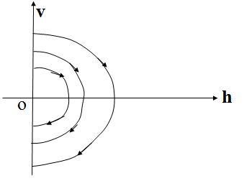
Figure 3. The phase portrait
of a free falling body

1.2. Models of dynamics of a biological population
1.2.1. Exponential model
At the end of the 18-th century the English philosopher and demographer T.R. Malthus after studying the statistics data for some previous years proposed the following assertion: the rate of world population’s growing was always directly proportional to the amount of world population, that is
$N^{'}=λN$ (1.3)
$λ$ being positive.
Indeed he had a reason. In statistical forms we usually can read the following phrases: “The birth rate for the last year is equal to 300 for 10,000 units of population, the death rate for the last year is equal to 200 for 10,000 units of population, so the rate of growing for the last year is equal to 100 for 10,000 units of population”. What does it mean?
On the one hand it means that for the 100,000 units of population the increase will be equal to 1,000 of units, for the 1,000,000 units of population the increase will be equal to 10,000 of units, and so on. On the other hand the rate of growing for the last two years will be equal to 200 for 10,000 units of population, the rate of growing for the last three years will be equal to 300 for 10,000 units of population, and so on. Summarizing these facts we can write the following formulae to reflect the growing of population $ΔN=0\text{.}\text{01}NΔt$, and
$N^{'}=0\text{.}\text{01}N\text{.}$ (1.4)
So the consideration of statistical data we made involves the following rather general model of population’s dynamics
$N^{'}=\text{aN}−\text{bN}=(a−b)N$, (1.5)
$a$ and $b$ being respectively the birth rate and the death rate.
Designating the rate of growing $λ=a−b$ we’ll receive the exponential law (1.3) proposed by T.R. Malthus.
We can say that the equation (1.3) represents some dynamical system.
Indeed, solving this equation we’ll find: the amount of the world population is growing in correspondence with the exponential law
$N(t)=N(0)\text{exp}(λt)$, (1.6)
$N(0)$ being the initial amount of the world’s population at the time t = 0. So we see that knowing of the initial state gives us the possibility to predict the amount of the world population for any time t > 0.
What is the phase space of the dynamical system (1.3)? Evidently it is the set of positive real numbers (when the amount of the world’s population is very great it’s more comfortable to mean by this way). In the case when $λ$ is positive the derivative $N^{'}(t)$ will be positive too, so the phase point $N(t)$ will move to the right in the phase space (see the figure 4).

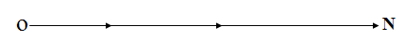
Figure 4. The phase portrait of exponential model with $λ$ positive
So we see the amount of the world’s population is increasing infinitely in accordance with the exponential model (1.3). We want to know how fast is this process? Let us consider the very important property of the exponential function $x(t)=x(0)\text{exp}(λt)$ with $λ>0$ and $x(0)>0$. Upon the time $τ=\frac{\text{ln}2}{λ}$ we’ll have the relation $x(t+τ)=2x(t)$, that is the exponent realizes the correspondence between the arithmetic progression $0,τ,2τ,3τ,\text{.}\text{.}\text{.}$ and the geometric progression $x(0),2x(0),4x(0),8x(0),…$. To illustrate the fantastic increasing of the exponential law I’ll tell you an old legend (from India) about the inventor of the chess game. The King receiving this game was very pleased and asked the inventor whether he could do anything to thank him for the present.
The inventor’s desire seemed to be easy. He asked the King to give him only one grain of wheat to put on the first square of the chessboard, only two grains of wheat to put on the second square of the chessboard, four grains of wheat to put on the third square of the chessboard, and so on, doubling the number of grains for each next square of the chessboard. He asked to cover all 64 squares of the board. The King was very surprised and said he would certainly fulfill this desire. He told his men to bring a bag full of wheat and to count the necessary amount of grains. But the bag was emptied before the 20-th square was covered with wheat! More bags were brought but the number of grains needed increased so rapidly that the King understood he would not be able to keep his word! The thing is that he would have to give about 4,000 billion of bushels of wheat to the inventor. Since the world production of wheat is equal at an average to 2 billion of bushels a year, the King could not keep his word.
Thus the King found he either had to remain constantly in debt to the inventor or cut his head off. The King thought it best to choose the latter alternative.
So the exponential model is not complete, it is impossible to imagine the infinite (or almost infinite) amount of people living on the Earth having limited dimensions. It is true not only for the human population but for any other biological population as well. Thus the exponential model of the development of any population must be improved by the reasonable way. It is clear that the unlimited increasing of any population on the bounded territory finally will involve the great density of population and as a consequence the worst conditions of its life.

1.2.2. Logistic model
The next model of development of some biological population (so called logistic law) proposes to replace the negative member $\text{bN}$ in the equation (1.5) by the term ${\text{bN}}^{2}$. As a result of we receive the logistic model:
$N^{'}=N(a−\text{bN})$ (1.7)
I am sure that you can easily find its solution. But it is not necessary for understanding the all possible kinds of processes defined by the equation (1.7). For these purpose it is sufficient to apply the notions of phase space and phase portrait. The phase space is the same that is the positive semi-axis N. But the phase portrait will differ (see the figure 5).
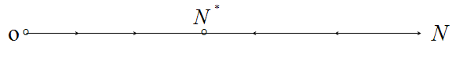
Figure 5. The phase portrait of logistic model.
If the amount of population $N<\frac{a}{b}$, then $N^{'}(t)>0$ and the phase point $N(t)$ will move to the right. If the amount of population $N>\frac{a}{b}$, then $N^{'}(t)<0$and the phase point will move to the left. The point $N^{}=\frac{a}{b}$will be the stable state of balance.
So we see that the logistic model is more realistic than the exponential one. If the amount of population is not large ($N<N^{}$) the conditions of life are comfortable and it is increasing. Otherwise ($N>N^{}$) the negative factors of life will be more significant than the positive ones and the amount of population will decrease.

1.2.3. Model of a disappearing population
It is known that there are some biological populations marked in so-called red book, which have very little number N. There exists a real fear that they will disappear if their number is less of some critical value. For this kind of population the mathematical model is constructed by the following way:
$N^{'}=N(\text{aN}−b)$ (1.8)
The phase space of this system is the positive semi-axis N.
If the amount of population $N<\frac{b}{a}$, then $N^{'}<0$ and the phase point will move to the left (that is to zero). If the amount of population $N>\frac{b}{a}$, then $N^{'}>0$ and the phase point will move to the right. The point $N^{}$will be the unstable state of balance (see the figure 6).

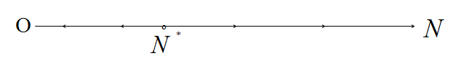
Figure 6. Phase portrait of disappearing population.
Note that the model (1.8) is not a complete model. It reflects only the fact of a possible disappearance of the population. That is why we need to construct a generalized model, where we will take in consideration the influence both little number and great number of population on its conditions of life.

1.2.4. Generalized model of dynamics of population
Let us consider the following model
$N^{'}=\frac{{\text{aN}}^{2}}{d+N}−\text{bN}−\text{cN}$, (1.9)
where the parameters $a, b, c, d$ are positive. The first member in the second part of this equation describes the rate of reproduction of this population (directly proportional to $N^{2}$ with small values of N and directly proportional to N with great values of N). The second member represents the rate of natural decreasing of the population and the third member reflects the internal competition between individuals of the population.
To investigate the phase portrait of this system we’ll transform the equation (1.9):
$N^{'}=\frac{−N({\text{cN}}^{2}+(b−a+\text{cd})N+\text{bd})}{d+N}\text{.}$ (1.10)
We have to determine the values of parameters $a, b, c, d$ in this way that the states of equilibrium would be real and positive. It means that the roots
$$N_{1,2}=\frac{−(b−a+\text{cd})±\sqrt{(b−a+\text{cd})^{2}−4\text{cbd}}}{2c}$$
of the equation ${\text{cN}}^{2}+(b−a+\text{cd})N+\text{bd}=0$ have to be real and positive. That’s why the parameters $a, b, c, d$ have to verify the inequality $a−b−\text{cd}>2\sqrt{\text{cbd}}$. If we take for example $a=\text{10}, b=1, c=1, d=4$ then the equation (1.10) will be the following:
$N^{'}=\frac{N(N−1)(N−4)}{4+N}$. (1.11)
Its phase portrait is presented in the figure 7.

Figure 7. The phase portrait of the system (1.11)

2. Water outflow from the vessel. Model of Torricelli
and its improvement
2.1. The model of Torricelli
Let us consider a very simple phenomenon of a water outflow from a cylindrical vessel with a small hole in its bottom (see the Figure 8). Let $S, s, H, h$ be the sectional area of the vessel, the area of the hole in the bottom, the height of the vessel and the height of water level accordingly (see the figure 8).
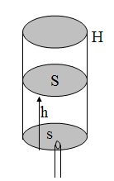
Figure 8. Vessel with a hole in the bottom
We are interested in how will the water level height $h(t)$ be changed if the water is flowing out and the initial value of the level is equal to H. In order to answer this question it is necessary to know the velocity V of the outflow through the hole. Indeed for a unit time the volume of the water to outflow is equal to $−{\text{Sh}}^{'}$ on the one hand and $\text{sV}$ on the other hand. So we receive the equation
${\text{Sh}}^{'}=−\text{sV}\text{.}$ (2.1)
With V known as a function of h, the above equation will be a differential equation. Three century ago the famous physicist Torricelli said “Water will flow out with the velocity $V=\sqrt{2\text{gh}}$ as if it would drop from the height $h$”.
So we receive the following differential equation
$h^{'}=−\frac{s}{S}\sqrt{2\text{gh}}$, (2.2)
that we’ll call the model of Torricelli.
Solving this equation (separating variables) we’ll have
$\begin{aligned}\frac{\text{dh}}{\sqrt{h}}=−\frac{s}{S}\sqrt{2g}\text{dt}, \\ 2\sqrt{h}=−\frac{s}{S}\sqrt{2g}t+C\text{.}\end{aligned}$
From the initial condition $h\left(0\right)=H$ we can find the constant C: $C=2\sqrt{H}$. Finally we have the solution of the equation (2.2) in the comfortable form
$h={\left[\sqrt{H}−\frac{s}{S}\left(\sqrt{\frac{g}{2}}\right)t\right]}^{2}$. (2.3)
This is the parabola with the bottom point $(t_{f},0)$ with
$t_{f}=\frac{S}{s}\sqrt{\frac{2H}{g}\text{.}}$ (2.4)
We take the part of this curve corresponding to the decreasing of h(see the figure 9).
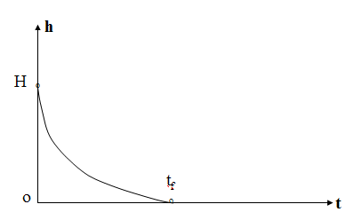
Figure 9. The change of water level
The water outflow mathematical model constructed above is a dynamical system. Its phase space will be the half-line $h≥0$. Its single phase trajectory is the same half-line $h>0$ with the phase point moving to left (see the figure 10). The second phase trajectory is the point O.
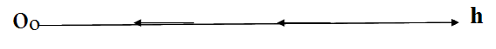
Figure 10. Phase portrait of the model of Torricelli
As a matter of fact we’ll note that the model of Torricelli (2.2) just as valid not only for the considered case with the constant sectional area of the vessel, but for the case $S=S(h)$ as well. Indeed the water balance in the vessel we can write in a more general form:
$V^{'}=−s\sqrt{2\text{gh}\text{.}}$ (2.5)
The water’s volume V for this case may be calculated by the following way: $V=\int_{0}^{h}{S\left(ξ\right)}dξ\text{.}$ So we’ll have $V^{'}=S\left(h\right)h^{'}$ and the formula (2.5) transforms to
$S\left(h\right)h^{'}=−s\sqrt{2\text{gh}}$. (2.6)

2.2. The improvement of the model of Torricelli
When the mathematical model is constructed it is useful to compare the results obtaining from this model with the experimental data. The most difference was noted between the real time $T_{f}$ of the vessel’s emptying and the time $t_{f}$ calculated by the formula (2.4). The real time $T_{f}$ was close to the value 1.3$t_{f}$. This difference was explicated very easily: the sectional area of the water flow is really less than the area of the hole. If we replace the value s in the model of Torricelli by the value $σ$ of the sectional area of the water flow the time calculated by the formula (2.4) will be close to the real time of the vessel’s emptying provided the values s (and $σ$) are very small with regard to the sectional area S that is $σ\text{<<}S$. Otherwise the difference arises. Moreover, the greater is the size s of the hole the more obvious is the incorrectness of the model of Torricelli.
Indeed, let us test this model for the very particular case when $σ=S$.
In this case water is merely falling down from the bottomless vessel in full agreement with the gravitation law. That is the water level $h\left(t\right)$, having the initial state $h\left(0\right)=H, h^{'}\left(0\right)=0$ will descend in according with the law
$h^{'}\left(t\right)=−\text{gt},h\left(t\right)=H−\frac{gt^{2}}{2}\text{.}$ (2.7)
Calculating the value of $h^{'}\left(t\right)$ under the law of Torricelli (2.2) we note that the $h^{'}\left(0\right)$ is equal to $−\frac{s}{S}\sqrt{2\text{gH}}$ at the beginning of process and $h^{'}\left(t_{f}\right)=0$ at its ending. Vice versa the value of $h^{'}\left(t\right)$ as it follows from (2.7) is equal to zero for t=0 and then $h^{'}=−{\text{gt}}_{f}$.
What is wrong with the model of Torricelli? To understand it we’ll investigate the process of water outflow more accurately [1] having the purpose to improve and precise the model of Torricelli.
The basic concept that we’ll use is the following: the sum of kinetic energy and potential energy is a constant while some body is moving in a potential field.
As we know the gravitational field of the Earth is potential. Let us consider the process of outflow of some mass $m\left(t\right)$ of water staying in the vessel at the moment $t$. Let S be the sectional area of vessel, $σ$ be the effective area of hole, $h\left(t\right)$ the height of water in the vessel at the moment of time $t$ and $h\left(t+Δt\right)$ the height of water in the vessel at the moment of time $t+Δt$ (see the figure 11).
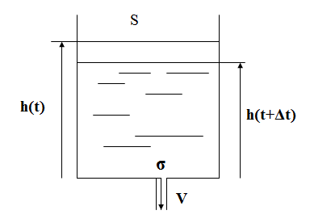
Figure 11. Outflow of water from the vessel
At first we’ll count the full mechanical energy $E\left(t\right)$ (that is the sum of kinetic energy $K\left(t\right)$ and potential energy $P\left(t\right)$) for the mass $m\left(t\right)$ staying in the vessel at the moment $t$. This mass may be presented by the formula $m\left(t\right)=ρ\text{Sh}\left(t\right)$, where $ρ$ is the density of water. So we have
$E\left(t\right)=ρ\text{Sh}\left(t\right)\frac{{\left(h^{'}\right)}^{2}}{2}+ρ\text{Sh}\left(t\right)g\frac{h\left(t\right)}{2}=ρ\text{Sh}\left(t\right)\left[\frac{{\left(h^{'}\right)}^{2}}{2}+g\frac{h\left(t\right)}{2}\right]\text{.}$ (2.8)
At the next moment of time $t+Δt$ the original mass $m\left(t\right)$ of water will be divided in two parts, the first one (the most of $m\left(t\right)$) $m\left(t+Δt\right)$ will stay in the vessel and the second one $−Δm=m\left(t\right)−m\left(t+Δt\right)$ will be out of the vessel.
The sum $E_{1}\left(t+Δt\right)$ of kinetic energy $K_{1}\left(t+Δt\right)$ and potential energy $P_{1}\left(t+Δt\right)$ for the mass $m\left(t+Δt\right)$ staying in vessel at the moment $t+Δt$ may be represented by the formula (2.8) with only replacement of t by $t+Δt$:
$E_{1}\left(t+Δt\right)=ρ\text{Sh}\left(t+Δt\right)\left[\frac{{\left(h^{'}\left(t+Δt\right)\right)}^{2}}{2}+g\frac{h\left(t+Δt\right)}{2}\right]\text{.}$ (2.9)
The full mechanic energy $E_{2}\left(t+Δt\right)$ for the second part of mass $−Δm$ which is equal to $\text{ρσ}VΔt$ may be represented in the form
$E_{2}\left(t+Δt\right)=\text{ρσ}VΔt\left[\frac{V^{2}}{2}−g\frac{VΔt}{2}\right]\text{.}$ (2.10)
In accordance with the energy conservation law we have
$E\left(t\right)=E\left(t+Δt\right)=E_{1}\left(t+Δt\right)+E_{2}\left(t+Δt\right)$. (2.11)
The formula (2.9) for $E_{1}\left(t+Δt\right)$ may be transformed using the relations $h\left(t+Δt\right)=h\left(t\right)+Δh, h^{'}\left(t+Δt\right)=h^{'}\left(t\right)+Δh^{'}$:
$$E_{1}\left(t+Δt\right)=E\left(t\right)+ρS\left(h\left(t\right)+Δh\right)\left[h^{'}Δh^{'}+\frac{{\left(Δh^{'}\right)}^{2}}{2}+g\frac{Δh}{2}\right]\text{.}$$
So the relation (2.11) becomes the following:
$$\begin{aligned}0=ρ\text{Sh}\left(t\right)\left[h^{'}Δh^{'}+\frac{{\left(Δh^{'}\right)}^{2}}{2}+gΔh\right]+ρSΔh\left[\frac{{h^{'}}^{2}}{2}+h^{'}Δh^{'}+\frac{{\left(Δh^{'}\right)}^{2}}{2}+g\frac{Δh}{2}\right]+ \\ +\text{ρσ}VΔt\left(\frac{V^{2}}{2}−g\frac{VΔt}{2}\right)\text{.}\end{aligned}$$
Dividing the last relation by $Δt$and tending $Δt$ to zero we’ll receive the following equation
$$ρ\text{Sh}\left(t\right)\left[h^{'}\left(t\right)h^{''}\left(t\right)+gh^{'}\right]+ρSh^{'}\frac{{\left(h^{'}\right)}^{2}}{2}+\text{ρσ}\frac{V^{3}}{2}=0\text{.}$$
Now it is time to use the relation (2.1) namely let us replace the value V by the value $−\frac{Sh^{'}}{σ}$ in the last relation. Besides we can divide it by the common factor $ρSh^{'}$. After that we’ll receive the following differential equation
$$hh^{''}+\text{gh}+\frac{{\left(h^{'}\right)}^{2}}{2}\left(1−\frac{S^{2}}{σ^{2}}\right)=0,$$
that we’ll write as a second-order equation:
$h^{''}=\frac{1}{h}\left[−\text{gh}+\frac{{\left(h^{'}\right)}^{2}}{2}\left(\frac{S^{2}}{σ^{2}}−1\right)\right]\text{.}$ (2.12)
We can see that this equation describes the case when $σ=S$ very well. Indeed when $σ=S$ the relation (2.12) becomes $h^{''}=−g$. That is we have the free falling down of the water.
But how this equation (2.12) describes the other cases including the main case when $σ\text{<<}S$? We’ll try now to understand it. Let us investigate the process described by the equation (2.12) with the following initial conditions: $h\left(0\right)=H, h^{'}\left(0\right)=0\text{.}$
That means that at the moment $t=0$ the hole is closed.
While the hole opens we have $h^{''}=−g$. So the speed of water level sinking at the beginning of the process will be $h^{'}=−\text{gt}$, that is ${\left(h^{'}\right)}^{2}$ will increase. If $\frac{S}{σ}\text{>>}1$ the expression in the braces in (2.12) will tend rather fast to zero:
$\frac{{\left(h^{'}\right)}^{2}}{2}\left(\frac{S^{2}}{σ^{2}}−1\right)−\text{gh}=0$, and
$h^{'}=−\frac{σ}{S}\sqrt{\frac{2\text{gh}}{1−\frac{σ^{2}}{S^{2}}}}$. (2.13)
The relation is very close to the model of Torricelli. Indeed, we receive the model of Torricelli from the equation (2.13) accepting the relation between $σ$ and S $σ\text{<<}S$.
Thus the process of water outflow when $σ\text{<<}S$ is divided in two parts: the first part we may name as the fast transitive part, when the speed of sinking of the water level is increasing from zero to the value $−h^{'}=\frac{σ}{S}\sqrt{2\text{gh}}$, but the second part we can name as a stationary process when the water level $h\left(t\right)$ will decrease with accordance to the model of Torricelli.
We can value the interval of time $τ$ of the first transitive part. Developing the function $h^{'}\left(t\right)$ to the series of Taylor we’ll receive $h^{'}\left(τ\right)≃h^{'}\left(0\right)+h^{''}\left(0\right)τ$.
From the above relation taking into account that $h^{'}\left(0\right)=0,h^{''}\left(0\right)=−g,h^{'}\left(τ\right)=−\frac{σ}{S}\sqrt{2\text{gH}}$, we’ll receive
$τ≃\frac{σ}{S}\sqrt{\frac{2H}{g}}$. (2.14)
Now we may to compare the value $τ$ and the time $t_{f}$ of the vessel emptying: $τ=t_{f}\frac{σ^{2}}{S^{2}}$.
If for example $σ=0\text{.}1S$, then $σ=0\text{.}\text{01}t_{f}$.Thus the value of the interval of the transitive process will be only 1% of the time of the vessel emptying.
To finish this investigation let us draw the phase portrait of the dynamical system represented by the equation (2.12) (see the figure 12). The phase space in the plane $\left(h,−h^{'}\right)$ will be determined by the following inequalities $h≥0,−h^{'}≥0\text{.}$
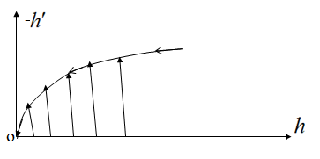
Figure 12. Phase portrait of process of emptying of vessel
We see that the process of emptying of the vessel consists of two movements: the fast one and the low one.
3. The system “inflow–outflow”. Simple model of a hydropower station
3.1. The system “inflow–outflow”
Let us consider the dynamics of the water level when the outflow through a bottom hole and a constant inflow of the intensity $Q$ are present. For this case the equation of water balance in the vessel will be the following $Sh^{'}=−σV+Q$.
If $σ\text{<<}S$ we have $V=\sqrt{2\text{gh}}$, so the differential equation may be written as $Sh^{'}=−σ\sqrt{2\text{gh}}+Q$.
This equation is easily integrated, but we’ll consider its phase portrait at the phase half-line $h≥0$.
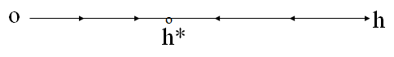
Figure 13. Phase portrait of the system “inflow-outflow”
It’s evident that this system has a point of equilibrium (see the figure 13).
Indeed, if $σ\sqrt{2\text{gh}}<Q$ we have $h^{'}>0$ and the vessel is filling, if $σ\sqrt{2\text{gh}}>Q$ we have $h^{'}<0$ and the vessel is emptying. So at the point $h^{}=\frac{Q^{2}}{2{gσ}^{2}}$ we have $h^{'}=0$. The phase point moves to the right from 0 to $h^{}$, and the phase point moves to the left from the infinity to the point $h^{}$. So the system has the stable state of equilibrium $h^{}$.

3.2. Siphon
Let us assume the water inflow to be equal to $Q$ and the water outflow to be performed not through the vessel bottom hole but through a so-called siphon, that is the σ-section tube bent in the way shown in the figure 14.
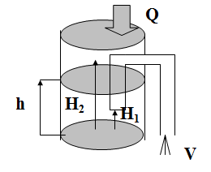
Figure 14. Outflow of water through a siphon
The siphon is a wonderful device to empty an incompletely filled container over its brims. Though, this may be only done when the siphon itself is filled with water.
Let us construct a mathematical model and find the conditions when this system will have oscillations. To construct a mathematical model of this device let us take the couple $\left(h\left(t\right),ξ\right)$ as its state, where $ξ=0$ if the siphon is empty and $ξ=1$ if the siphon is filled.
$$Sh^{'}=\left\{\begin{matrix}\begin{matrix} & & \end{matrix}Q,\begin{matrix} & & \end{matrix} \\ −σ\sqrt{2\text{gh}}+Q,\end{matrix}\right.\begin{matrix}\text{if} h<H_{1}, \text{or} H_{1}<h<H_{2} \text{and} ξ=\text{0,} \\ \text{if} h>H_{2}, \text{or} H_{1}<h<H_{2} \text{and} ξ=1\text{.}\end{matrix}$$
Let us suppose that the value $h^{}=\frac{Q^{2}}{2{gσ}^{2}}$ be less than $H_{1}$. So if the initial condition is $h(0)=0$ then we have the equation
$Sh^{'}=Q$ (3.1)
till the moment $t_{1}$ when $h\left(t_{1}\right)=H_{2}$. The phase space of the system (3.1) is presented below.
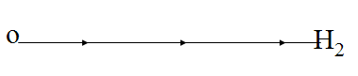
Beginning this moment the siphon will be filled with water and the process will be described by the equation
$Sh^{'}=−σ\sqrt{2\text{gh}}+Q$, (3.2)
where $Q<σ\sqrt{2\text{gh}}$, because $h>h^{}$.
So the level of water $h(t)$ will become lower till the moment $t_{2}$ when $h\left(t_{2}\right)=H_{1}$. The phase space of the system (3.2) is presented below.
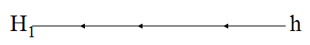
Beginning this moment the siphon will become empty and the process will be described by the equation (3.1) and so on. We have received so-called auto-osсillations. The phase space of the siphon is presented below.
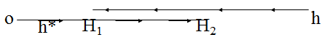

3.3. Simple model of a hydropower station
Any hydropower station is a very complicated object, having a water reservoir, a dam equipped by a turbines and electric generators. But we’ll try to construct a simple model [1] using some facts and notions from the preceding topic. The reservoir has some water inflow of the intensity $Q$ assumed constant. From the reservoir water runs through a tubular corridor to the turbines and turns them round (see the figure 15). The electrical generators connected to the turbines produce electrical current of the power $W$. Our target is to study how the variation of the water level influence the stable work of the station.
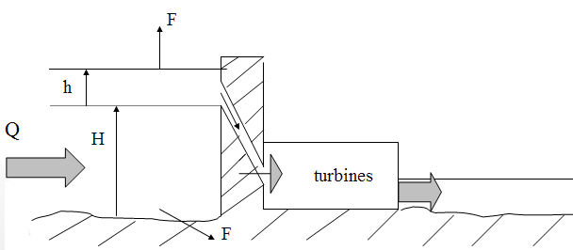
Figure 15. Scheme of a hydropower station
The equation of the water balance in the reservoir may be written in the form likewise as for the system “inflow – outflow”:
$Sh^{'}=Q−F\left(h\right)−\frac{W}{kρg\left(H+h\right)}$ (3.3)
The symbols used in the equation (3.3) designate:
$S$ – the area of reservoir surface,
$H$ – the minimal height of the water level,
$\left(H+h\right)$ – the real height of the water level,
$Q$ – the intensity of the water inflow,
$F(h)$ – the intensity of water evaporation (filtration),
$W$ – the power of the electric hydro-station,
$k$– the station efficiency coefficient,
$ρ$– the density of water,
$g$– the constant (the acceleration of free fall).
It’s only the last term in the equation (3.3) that we need to explain. Let $m(h)$ be the mass of water outflow from the tubular corridor hole to the turbines and $V$ its speed. Then this mass possesses the kinetic energy $E=\frac{mV^{2}}{2}$. The value $V$ may be defined by the law of Torricelli $V=\sqrt{2g\left(H+h\right)}$, so the energy $E$ of the mass $m(h)$ will be equal to $m\left(h\right)g\left(H+h\right)$. Remembering that $k$ is the station’s efficiency coefficient, we’ll receive the relation $W=\text{km}\left(h\right)g\left(H+h\right)$. So the mass $m(h)$ of water outflow needed for production of the electric power $W$ will be determined by the formula $m\left(h\right)=\frac{W}{\text{kg}\left(H+h\right)}$, and its volume will be equal to the value $\frac{W}{kρg\left(H+h\right)}$ used in the equation (3.3).
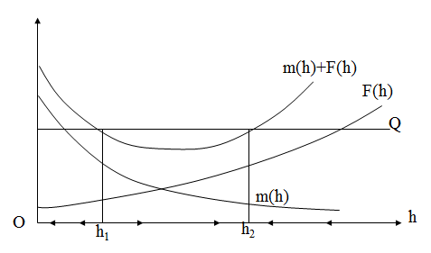
Figure 16. Phase portrait of the system (3.3)
Now let investigate the dynamical system (3.3) using the notion of phase portrait. Note that here the phase space is the half-line $h≥0$. Over this half-line we’ll draw the graphs of the functions staying in the right part of the equation (3.3) (see the figure 16).
Evidently $F\left(h\right)$ is an increasing function. At the interval $\left(h_{1},h_{2}\right)$ of the axis $h$ we have the inequality $h^{'}>0$ because $Q−F\left(h\right)−m\left(h\right)>0$. So the phase point moves to the right from the point $h_{1}$ to the point $h_{2}$. At the intervals $\left(0,h_{1}\right)$ and $\left(h_{2},∞\right)$ the phase point moves to the left. So we see that the state $h_{2}$ is stable but the state $h_{1}$ is not stable. If $h<h_{1}$ the phase point will move to the zero. That means the danger for the electric station. This situation may be if the value $Q$ of the inflow will decrease. In order to let the station continuing the production of the electric energy we must to reduce the value $W$ of the electric power.

4. Energetic model of the heart. Soiling a water reservoir with a bay
4.1 Energetic model of the heart
To begin with I would like to say that mathematical models of the heart are very needed for the contemporary medicine in order to understand how to help the heart in the so-called emergency situations. There are some models that are able to simulate different aspects of the complicated activity of the heart. The chief of our department (Department of the control theory) prof. Osipov G.V. is constructing and analyzing a model of the heart’s surface as an ensemble of weakly linked neurons and studying their synchronization.
We’ll consider a simple model of the heart [1] proposed by the professor of our department Y.I. Neimark. This model is simple but it may give some general representation about the heart’s activity. The heart is a four-chamber pump supplying blood for the entire organism. One half of the heart pumps blood along the so-called small circle that is through the lungs enriching blood with oxygen. Another half of the heart is responsible for supplying all human organs with arterial blood filled with oxygen. It is so-called large circle of the blood circulation. Though the heart is not simple pump, it is the pump controlled by the commands from the central nervous system. The control system of the heart performs a coordination of the blood pumping across the large and small circles.
The heart transforms the chemical energy into the mechanical energy. So we can say that the heart lives only because it feeds itself through its functioning. Accordingly that, the heart may be described only by two variables: by the control command $u$ being executed by the heart and by its current energy stock $Q$ being spent for heart’s running and replenished by the blood circulating through the heart.
In according with the above description we may write the following differential equation
$Q^{'}=−a−f\left(u,Q\right)+g\left(u,Q\right)\text{.}$ (4.1)
In this equation the function $f(u,Q)$ represents the intensity of consuming the energy $Q$ depending on the control $u$ and the value $Q$.
We suppose $f(u,Q)$ to be increasing function of both arguments, and $f\left(0,Q\right)=f\left(u,0\right)=0$.
The function $g\left(u,Q\right)$ represents the intensity of replenishment of the energy by the blood incoming to the heart from the small circle. It’s naturally to suppose that $g\left(0,Q\right)=g\left(u,0\right)=0$. The presence of the constant a means that nonfunctioning heart is consuming the energy for some interval of time. We don’t know how the variable $u$ will change. The central nervous system is not studied well. We’ll suppose for the simplicity that
$u^{'}=0$, (4.2)
that is the value of $u$ for some interval of time will be a constant.
Furthermore we’ll suppose that the values of our variables are restricted: $0≤u≤U,0≤Q≤E$. So we may say that the set of all states of our system (that is the phase space) is determined (see the Figure 17).
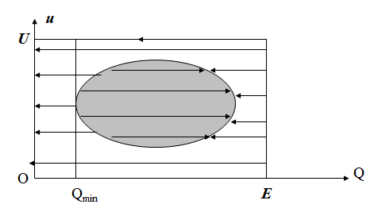
Figure 17. Phase portrait of the heart
Let us investigate the phase space having the purpose to draw the phase portrait of our system (see the figure 17).
At first we note that the phase trajectories have to be horizontal lines. Now we must determine in what direction the phase point will be moving. It is natural to assume that for $u=U$ the heart will be fast exhausted, so $Q^{'}<0$ and the phase points will move to the left. For the values of the variable u close to U the phase point will be moving to the left as well. The same result we’ll have for the value $u=0$ and for value u close to zero, because $Q^{'}<0$ if $f\left(0,Q\right)=g\left(0,Q\right)=0$.
Since $Q$ cannot exceed $E$ then for all points of the side $Q=E$ we’ll have $Q^{'}<0$. The side $Q=0$ means the state of nonfunctioning heart, but the nonfunctioning heart is consuming the energy for some interval of time.
And meanwhile we live a long life! Thus there should exist some domain $G$ inside the phase space where $Q^{'}$ must be positive! This domain is represented in the above figure. The phase points are moving to the right in this domain. An exact boundary of this domain is certainly unknown. For each person the dimensions of the rectangle $0≤u≤U,0≤Q≤E$ and of the domain $G$ are different.
It depends on many causes and circumstances. So any phase point being out of the domain $G$ and traveling to the left will arrive either the side $Q=0$ or the right part of the domain $G$ boundary.
Observing the possible motions of the phase point we may note that it would be dangerous to have the value of u close to 0 and U, as well as to have the value of $Q$ less than $Q_{\text{min}}$.
The most dangerous part of the domain $G$ is that one where $Q<Q_{\text{min}}$ because here the phase point will arrive the side $Q=0$ independently of the variations of the control u.
When $Q>Q_{\text{min}}$ we always may to come into the domain $G$ changing the value of the control u. If u is close to U it means a critical state of the heart having an enormous load (as the heart of a sportsman during a race).
So it’s necessary to decrease it before the phase point arrive the part where $Q<Q_{\text{min}}$.
When u is close to 0 it means a durable weak activity of the heart. It may be caused by a lack of training, a general exhaustion of the organism and so on. In this case it’s necessary to load softly the heart by moderate training. The training will increase the efficiency coefficient of the heart’s muscle, the values of the function $g\left(u,Q\right)$ and finally the dimensions of the domain $G$.

4.2. Soiling a water reservoir with a bay
The next problem to be discussed is a very usual ecological problem [1]. There are some rivers falling into a lake. There are some towns disposed along these rivers. So the water of these rivers maintains some quantity of soil and unhealthy substances (particles). The Caspian Sea is the most known example of this problem. Let $Q$ be an intensity of the Volga’s flow coming into the Caspian Sea, and $α$ be a concentration of the unhealthy substances in the Volga’s water. Note that the Caspian Sea has a bay (Cara-Bogaz-Gol). The bay’s level of water surface is lower than the level of water surface of the Caspian Sea.
Further, let V and W be the volumes of the Caspian Sea and its bay respectively, E and F be the intensities of water evaporation from the surfaces of Caspian Sea and its bay, G be the intensity of water outflow from the Caspian Sea into the bay. It’s clear that E have to be an increasing function on V, F have to be an increasing function on W, G have to be an increasing function on V and decreasing function on W. So we may write the equations for the balances of water’s volumes:
$$V^{'}=Q−E\left(V\right)−G\left(V,W\right),$$
$W^{'}=G\left(V,W\right)−F\left(W\right)\text{.}$ (4.3)
Let $β\left(t\right)$ and $γ\left(t\right)$ be concentrations of the unhealthy substances in the Caspian Sea and its bay respectively.
So these functions will satisfy the equations:
$$Vβ^{'}=αQ−βG\left(V,W\right),$$
$Wγ^{'}=βG\left(V,W\right)\text{.}$ (4.4)
The system (4.3)–(4.4) consists of 4 equations and describes a water balance and a balance of the unhealthy substances in the Caspian Sea and its bay. So it seems a rather complicated model. But the system (4.3) does not include the variables $β\left(t\right)$ and $γ\left(t\right)$. That’s why we may investigate at first only the system (4.3). Let us consider the phase space of the first equation of the system (4.3) provided the value W be a constant. If the value V is small the Caspian Sea’s level of water surface will be lower than the bay’s one.
In this case the value $E\left(V\right)$ will be small and the value $G\left(V,W\right)$ will be negative! So the derivative $V^{'}$ will be positive and the phase point will be moving to the right. On the contrary for some great values of V the functions $E\left(V\right)$ and $G\left(V,W\right)$ will have great values as well.
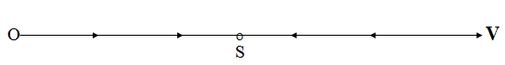
So the derivative $V^{'}$ will be negative and the phase point will be moving to the left. It means there exist a point of stable equilibrium S corresponding to a value $V_{S}$ such that
$V^{'}=Q−E(V_{S})−G\left(V_{S},W\right)=0\text{.}$ (4.5)
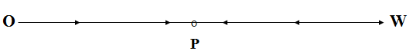
By the same way we’ll consider the phase space of the second equation of the system (4.3) provided the value V being equal to $V_{S}$.
There exist a point P of a stable equilibrium corresponding to a value $W_{P}$ such that
$W^{'}=G(V_{S},W_{P})−F(W_{P})=0\text{.}$ (4.6)
Assuming a presence of this stable state of equilibrium $(V_{S},W_{P})$ we come to analyze the system (4.4), which now has the form:
$$V_{S}β^{'}+Gβ=αQ,$$
$W_{P}γ^{'}=βG\text{.}$ (4.7)
In the system (4.7) the value $G=G(V_{S},W_{P})$ is a constant.
The first equation of the system (4.7) is a linear differential equation, its general solution has a form:
$β\left(t\right)=C\text{exp}\left(−\frac{G}{V_{S}}t\right)+\frac{αQ}{G}\text{.}$ (4.8)
It is easy to see that $\text{lim}β\left(t\right)=β^{}=\frac{αQ}{G}$ when t tends to infinity. It means that the concentration of the unhealthy substances in the Caspian Sea is not increasing infinitely, it tends to a finite amount $β^{}$. We’ll try to evaluate this amount using the relations (4.5) and (4.6).
$$β^{}=\frac{α\left(E+G\right)}{G}=\frac{α\left(E+F\right)}{F}=α\left(1+\frac{E}{F}\right)\text{.}$$
Because the intensities of evaporation E and F are proportional to the areas of surfaces H and L of Caspian Sea and its bay we can replace the fraction $\frac{E}{F}$ by the fraction $\frac{H}{L}$. For the Caspian Sea and its bay the value of the fraction $\frac{H}{L}$ is equal to 39.
So we have received an approximate formula $β^{}≃\text{40}α$ for the limit amount of the concentration of the unhealthy substances in the Caspian Sea’s water. As for the concentration $γ\left(t\right)$ of the unhealthy substances in the bay we can see from the second equation of the system (4.7) that it tends to infinity when $t→∞\text{.}$

5. Linear oscillator. Phase portraits
A linear oscillator is a very simple mathematical model wonderful by its variety and width of specific interpretations and applications. A linear oscillator describes periodic harmonic oscillations, dissipative and divergent oscillations, various types of equilibriums (like focus, center, node and saddle).
A mathematical model for a linear oscillator is a linear second-order equation:
$x^{\text{\} \} +2δx rSup \{ size 8\{'\} \} +βx=0\} \{}}$ (5.1)
Its phase space is the plane ($x,x^{'}$).
The simplest physical objects described by the equation (5.1) are a spring- attached mass m and an electrical circuit. Let us consider the first object (see the figure 18).
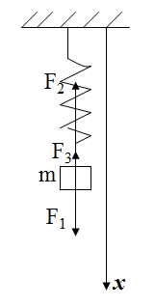

Figure 18. A spring-attached mass

According to the second law of Newton we can write the following equation $\text{ma}=F_{1}+F_{2}+F_{3}$, where the symbols $a, F_{1}, F_{2}, F_{3}$ mean respectively an acceleration of the mass m, a gravitation force, an elasticity force and a resistance force. Having the axis x we may write the above equation as a scalar equation
${\text{mx}}^{\text{''}}=\text{mg}−k(x−L)−{\text{cx}}^{'}\text{.}$ (5.2)
Here k is the elasticity coefficient, $(x−L)$ is the value of the spring extension and ${\text{cx}}^{'}$ is the value of the resistance force provided it being directly proportional to the speed of the mass m. After simplifying the equation (5.2) we’ll receive
$x^{\text{\} \} +2δx rSup \{ size 8\{'\} \} +βx=g+ \{ ital }kL\text{\} wideslash \{m\} \} \{}}$ (5.3)
After the change $x=y+L+\text{mg}k$ we’ll receive the equation of a linear oscillator
$y^{\text{\} \} +2δy rSup \{ size 8\{'\} \} +βy=0\} \{}}$, (5.4)
with $δ=c2m$ and $β=km$. The second physical object is an electrical circuit with a capacitor C, a self-induction L and a resistor R (see the figure 19).
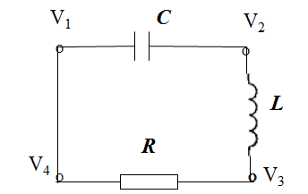

Figure 19. An electrical circuit

In accordance with the Kirchhoff’s voltage law we can say that the sum of all potential differences around any closed circuit must be equal to zero.
So we can write $(V_{1}−V_{2})+(V_{2}−V_{3})+(V_{3}−V_{4})=0$. If we change in this relation the value $V_{4}$ by the value $V_{1}$ this relation will be obvious. But every potential difference has its proper physical sense:
$(V_{1}−V_{2})=qC$, where q is the value of the electrical charge of the capacitor;
$(V_{2}−V_{3})={\text{LI}}^{'}$, where I is the value of the current force;
$(V_{3}−V_{4})=\text{RI}$, (the Ohm’s law).
So we obtain the equation
$qC+{\text{LI}}^{'}+\text{RI}=0$. (5.5)
Because $q^{'}=I$, the equation (5.5) we can write in the form:
$q^{\text{\} \} + \backslash ( \{R\} wideslash \{L\} \backslash ) q rSup \{ size 8\{'\} \} + \backslash ( \{1\} wideslash \{ ital }LC\text{\} \backslash ) q=0\} \{}}$ (5.6)
It’s not difficult to see that we have a linear oscillator. Let us investigate how the phase portrait of the linear oscillator (5.1) depend on the values of the parameters δ and β . As you know the solution of the equation (5.1) has the simple form $x=e^{λt}$ where λ is any of the roots $λ_{1}=−δ+\sqrt{δ^{2}−β}, λ_{2}=−δ−\sqrt{δ^{2}−β}$ of the so-called characteristic equation
$λ^{2}+2\text{δλ}+β=0\text{.}$ (5.7)
If $δ^{2}>β$ we have two real different roots and the general solution will be any linear combination of two particular solutions:
$x(t)=C_{1}e^{λ_{1}t}+C_{2}e^{λ_{2}t}$. (5.8)
In order to depict the phase trajectories in the phase plane (x, y) with $y=x^{'}$ we’ll find:
$y(t)=C_{1}λ_{1}e^{λ_{1}t}+C_{2}λ_{2}e^{λ_{2}t}$. (5.9)
The equation (5.1) of a linear oscillator may be represented as the linear system
$x^{'}=y(t) y^{'}=−βx−2δy$. (5.10)
This system has the only state of equilibrium: x = 0, y = 0. The kind of this state depend on the values of the roots λ₁ and λ₂ of the characteristic equation (5.7).
We begin to study the types of the state of equilibrium (0,0) for the case when the roots are real and different.
It’s not difficult to note two very simple trajectories. The first one $y=λ_{1}x$ we’ll receive if C₂ = 0. The second one $y=λ_{2}x$ we’ll receive if C₁ = 0.
The case 1: $λ_{1}<0, λ_{2}<0, (δ>0, β>0, δ^{2}>β)$.
The phase point (x(t),y(t)) moving along the trajectories described by (5.8) and (5.9) including the both lines $y=λ_{1}x$, $y=λ_{2}x$ tends to the origin (0,0) when the time increases (see the figure 20). This state of equilibrium is named as stable node.

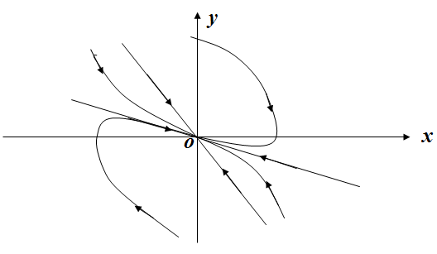
Figure 20. Phase portrait of a stable node
The case 2: $λ_{1}>0, λ_{2}>0, (δ<0, β>0, δ^{2}>β)$.
The phase point (x(t),y(t)) moving along the trajectories described by (5.8) and (5.9) including the both lines $y=λ_{1}x$, $y=λ_{2}x$ tends to the origin (0,0) when the time decreases to $−∞$, and tends to the infinity when time increases to $+∞$ (see the figure 21).This state of equilibrium is named as unstable node.
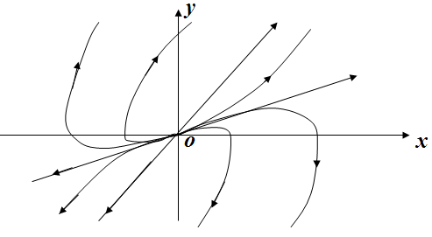
Figure 21. Phase portrait of an unstable node
The case 3: $λ_{1}>0, λ_{2}<0, (β>0)$.
The phase point (x(t),y(t)) moving along the trajectories described by (5.8) and (5.9) except the line $y=λ_{2}x$ tends to the infinity when time increases, but the phase point staying on the line $y=λ_{2}x$ tends to the origin (0,0), when time increases. This state of equilibrium is named as saddle (see the figure 22).
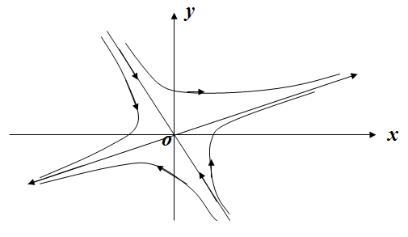
Figure 22. Phase portrait of a saddle
The other three kinds of equilibrium states are concerned with the complex roots of the characteristic equation (when $β>δ^{2}$):
$λ_{1}=−δ+i\sqrt{β−δ^{2}}, λ_{2}=−δ−i\sqrt{β−δ^{2}\text{.}}$ (5.11)
In this case using the symbol $Ω=\sqrt{β−δ^{2}}$ the solution of the equation (5.1) will be written in the form:
$x(t)=e^{−δt}(C_{1}\text{cos}Ωt+C_{2}\text{sin}Ωt)\text{.}$ (5.12)
The case 4: $δ=0, β>0\text{.}$
The equation of the linear oscillator for this case will be easier:
$x^{\text{\} \} +βx=0\} \{}}$. (5.13)
The equation of the trajectories we can find by the following kind:
$$\begin{aligned}x^{\text{\} \} x rSup \{ size 8\{'\} \} +β ital }xx\text{ rSup \{ size 8\{'\} \} =0,\sim left [ \backslash ( x rSup \{ size 8\{'\} \} \backslash ) rSup \{ size 8\{2\} \} size 24\{/\}2+βx rSup \{ size 8\{2\} \} size 24\{/\}2 right ] rSup \{ size 8\{'\} \} =0,\} \{\} \# \backslash ( x rSup \{ size 8\{'\} \} \backslash ) rSup \{ size 8\{2\} \} size 24\{/\}2+βx rSup \{ size 8\{2\} \} size 24\{/\}2=R,\sim y rSup \{ size 8\{2\} \} size 24\{/\}2R+x rSup \{ size 8\{2\} \} size 24\{/\} size 14\{ \backslash ( \} size 12\{2R\} size 24\{/\}β \backslash ) =1 \{\} \} \} \{}} \\ \end{aligned}$$
So the trajectories of the equation (5.13) form a family of ellipses.
This kind of the equilibrium is named as a center (see the figure 23).
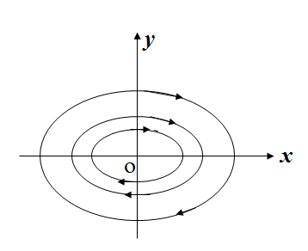
Figure 23. Phase portrait of a center
The case 5: $δ>0, β>δ^{2}\text{.}$
Now we can calculate:
$$\begin{aligned}x^{\text{\} \} +βx= - 2δx rSup \{ size 8\{'\} \} ,\sim x rSup \{ size 8\{}}x^{'}+β{\text{xx}}^{'}=−2δ(x^{'})^{2}, \\ {\left[(x^{'})^{2}2+{βx}^{2}2\right]}^{'}=−2δ(x^{'})^{2}, (x^{'})^{2}2+{βx}^{2}2=R(t), \end{aligned}$$
$y^{2}2R(t)+x^{2}(2R(t)β)=1$ (5.14)
The function R(t) is positive and decreasing. It means that the phase point will pass with the increasing t from the large ellipses to the small ellipses (see the figure 24). This case corresponds to a stable focus.
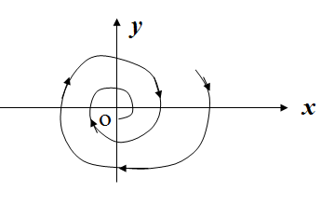

Figure 24. Phase portrait of a stable focus

The case 6: $δ<0, β>δ^{2}\text{.}$
In this case we’ll receive the same equation (5.14) of the trajectories but the function R(t) will be positive and increasing. So the phase point will transfer with the increasing t from the small ellipses to the large ellipses. This kind of a state of equilibrium is named as unstable focus (see the figure 25).
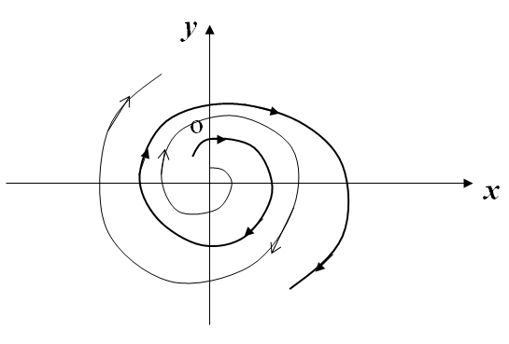
Figure 25. Phase portrait of an unstable focus
It’s useful to note, that the last three cases correspond to oscillating movements of the linear oscillator. For these cases we’ll use the notation $β=ω^{2}\text{.}$
So the equation of the linear oscillator takes the form
$x^{\text{\} \} +2δx rSup \{ size 8\{'\} \} +ω rSup \{ size 8\{2\} \} x=0\} \{}}$. (5.15)
If the value of the friction’s coefficient δ is rather small (with respect to the value of ω²) the value of $Ω=\sqrt{ω^{2}−δ^{2}}$ in (5.12) will be almost equal to ω . That’s why the value of ω is called sometimes the proper frequency of oscillations of the linear oscillator.
6. Forced oscillations. APFC. Resonance
We have got acquainted with the simplest physical applications of a linear oscillator that is a spring-attached mass and an electrical circuit. Now, we are going to study how these objects will be moving under the influence of some harmonic force $F=A\text{cos}(νt)$ (see the Figure 26) and some harmonic voltage $V=A\text{cos}(νt)$ (see the Figure 27) respectively.
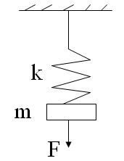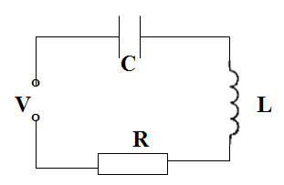
Figure 27. An electrical circuit under influence
of harmonic voltage
Figure 26. A spring-attached mass under influence
of harmonic force
In both cases, a mathematical model will be the same:
$x^{\text{\} +2δx rSup \{'\} +ω rSup \{2\} x=A}cos\text{ \backslash ( νt \backslash ) }.\text{ \} \{}}$ (6.1)
For the sake of simplicity we shall use a complex form of notations, through replacing the equation (6.1) by the equation
$x^{\text{\} \} +2δx rSup \{ size 8\{'\} \} +ω rSup \{ size 8\{2\} \} x= ital }Ae\text{ rSup \{ size 8\{iνt\} \} }.\text{ \} \{}}$ (6.2)
This equation may be understood in the following way: its real part is the equation (6.1); $A\text{cos}(νt)$ is the real part of ${\text{Ae}}^{iνt}$; and the solution x in (6.1) is the real part of the complex solution $x=x_{1}(t)+{\text{ix}}_{2}(t)$ in (6.2).
A general solution of the equation (6.2) includes a general solution of the corresponding homogeneous equation and any particular solution of the equation (6.2).
We shall search this particular solution in the form ${\text{Be}}^{iνt}$ that is as oscillations of the same frequency ν as the external force ${\text{Ae}}^{iνt}$ has. The direct substitution will give us the equation
$(−ν^{2}+2\text{δν}i+ω^{2})B=A,$ so
$B=A(−ν^{2}+2\text{δν}i+ω^{2})\text{.}$ (6.3)
The general solution of (6.2) is assumed to be disappearing as $t→∞$ (it’s the case for δ > 0), then the general solution with the increase of time will coincide with the particular solution:
$x={\text{Be}}^{iνt}=\left[A(−ν^{2}+2\text{δν}i+ω^{2})\right]e^{iνt}\text{.}$ (6.4)
The complex function $K(iν)=BA=1(−ν^{2}+2\text{δν}i+ω^{2})$ on the frequency $ν$ is called as amplitude-phase frequency characteristic (APFC). What does it means? Only the real part of (6.4) has an actual sense.
Let us determine it (preserving its denotation x):
$$\begin{aligned}x=\text{Re}\left\{B(iν)e^{iνt}\right\}=\text{Re}\left\{\left|B(iν)\right|e^{i(νt+ϕ)}\right\}= \\ \left|B(iν)\right|\text{cos}(νt+ϕ), \text{where} ϕ=\text{arg}B(iν)\text{.}\end{aligned}$$
Thus, the particular solution of the equation (1) is a harmonic oscillation with the frequency ν of the external force, with the amplitude $\left|B(iν)\right|=A\left|K(iν)\right|$ and with the phase displacement $ϕ=\text{arg}K(iν)$. The amplitude-phase frequency characteristic (APFC) may be made geometrically visual. Let us draw its locus, that is a curve being run on the complex plane W by the complex point $w=K(iν)$ while ν is varying from zero to infinity. The length of the radius-vector for the point w corresponding to the frequency ν will show how changes the original amplitude A and the angle between this vector and the real axis will be the phase displacement for the forced oscillations.

The locus of APFC for a linear oscillator may be easily depicted using the expressions for $\text{Re}K(iν)$ and $\text{Im}K(iν)$:
$$\begin{aligned}\text{Re}K(iν)=(ω^{2}−ν^{2})\left[(ω^{2}−ν^{2})^{2}+4ν^{2}δ^{2}\right] , \\ \text{Im}K(iν)=−2\text{δν}i\left[(ω^{2}−ν^{2})^{2}+4ν^{2}δ^{2}\right] \text{.}\end{aligned}$$
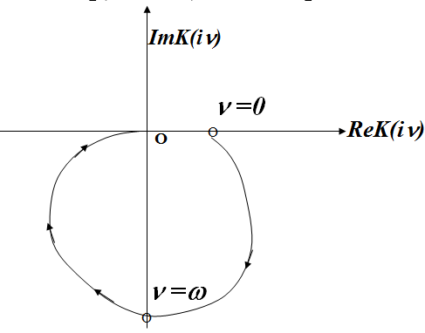
Figure 28. Locus of APFC for a linear oscillator
The locus begins in the point $w=1/{ω^{2}}$ (for ν = 0), runs down with increasing ν , passes through the point $w={−i}/2\text{δν}$ (for $ν=ω$) and terminates in the point w = 0 (for $ν→∞$).With the APFC being known we can easily plot an amplitude dependence $A\left|K(iν)\right|$ and a phase dependence $ϕ=\text{arg}K(iν)$ on the external disturbance frequency ν. It’s not difficult to find the formula for the amplitude: $A\left|K(iν)\right|=A\sqrt{(ω^{2}−ν^{2})^{2}+4ν^{2}δ^{2}} \text{.}$
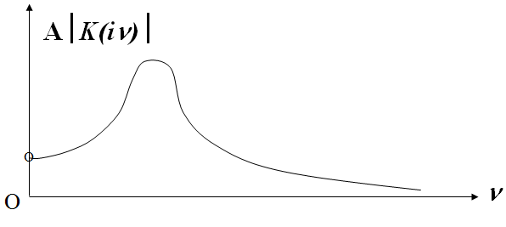
Figure 29. Phenomena of a resonance
This function has the maximum value $A2δ\sqrt{ω^{2}−δ^{2}}$ in the point $ν=\sqrt{ω^{2}−2δ^{2}}$. As we see the effect of a resonance is the more evident the less the value δ of the damping coefficient is. As regards a phase dependence $ϕ=\text{arg}K(iν)$ we can easily draw the graph of this function using the locus of $K(iν)$.
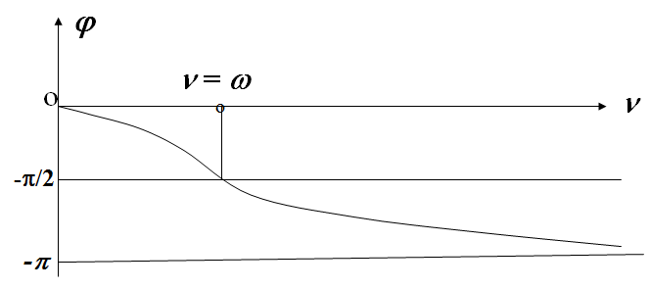
Figure 30. Dependence of phase displacement on external frequency

7. Dynamics of coexistence of two populations
7.1. Mathematical model of the type “predator – prey”
The first ecological model describing dynamics of a biological system, in which two species interact, was the “predator-prey” model constructed by Volterra and Lotka in 1928:
$$x^{'}=\text{ax}−\text{bxy},$$
$y^{'}=−\text{cy}+\text{dxy},$ (7.1)
where y is the number of some predator (for example, foxes); x is the number of its prey (for example, rabbits); $x^{'}$ and $y^{'}$ represent the growth of these populations; $a, b, c, d$ are positive parameters.
This antagonistic model assumes that population of preys can exist independently, but population of predators exists only through eating the preys.
The predators eat the more preys, the more numerous the preys are and the more numerous the predators are.
The quantity of preys eaten will promote a reproduction of predator.
For $y=0$ the quantity x will exponentially increase $x=x_{0}e^{\text{at}}$, whereas for $x=0$ the quantity y will exponentially decrease $y=y_{0}e^{−\text{ct}}$.
The phase space of the system (7.1) will be the octant $x≥0$, $y≥0$ of the plane (x, y).
Let us find the points of equilibrium:
$$\text{ax}−\text{bxy}=0,$$
$$−\text{cy}+\text{dxy}=0\text{.}$$
There are two points of equilibrium: (0, 0) and (c/d, a/b).
In order to determine the type of any point $(x^{},y^{})$ of equilibrium for a non-linear system
$$x^{'}=P(x,y),$$
$y^{'}=Q(x,y)\text{.}$ (7.2)
it’s necessary to perform its linearization in a neighborhood of this point:
$$x^{'}=P_{x}^{'}(x^{},y^{})(x−x^{})+P_{y}^{'}(x^{},y^{})(y−y^{}),$$
$y^{'}=Q_{x}^{'}(x^{},y^{})(x−x^{})+Q_{y}^{'}(x^{},y^{})(y−y^{}),$ (7.3)
and determine the kind of the point of equilibrium $(x^{},y^{})$ for this linear system.
It must be pointed out that the type of the point of equilibrium $(x^{},y^{})$ for this linear system and for the system (7.2) will be the same except for the case “center”. If the point $(x^{},y^{})$ is a “center” for the linear system, this point may be “center” or “focus” (both stable or not stable) for the system (7.2).
For the case when the second parts of the system (7.2) are polynomials the process of linearization may be performed with aid of the change of the variables:
x = X + x∗, y = Y + y∗.
Linearization of the system (7.1) in a neighborhood of (0,0) is very simple: the members bxy and dxy are infinitesimals of the second order.
So the linear system will be as follows:
$$x^{'}=\text{ax},$$
$y^{'}=−\text{cy}\text{.}$ (7.4)
The matrix $A=\left[\begin{matrix}a & 0 \\ 0 & −c\end{matrix}\right]$ has the eigenvalues $λ_{1}=a$, $λ_{1}=−c$. As the sign of the eigenvalues will always differ this point of equilibrium O (0,0) will be a saddle. The corresponding eigenvectors are (1,0)^{T} (the axis Ox) and (0,1)^{T} (the axis Oy).
As for the second point of equilibrium we’ll use the change of variables: $x=X+c/d, y=Y+a/b\text{.}$
With this change of variables the system (7.1) will transform to the system
$$X^{'}=(−{\text{bc}}/d)Y−\text{bXY},$$
$Y^{'}=({\text{ad}}/b)X−\text{dXY},$ (7.5)
and the corresponding linear system will be such:
$$X^{'}=(−{\text{bc}}/d)Y,$$
$Y^{'}=({\text{ad}}/b)X\text{.}$ (7.6)
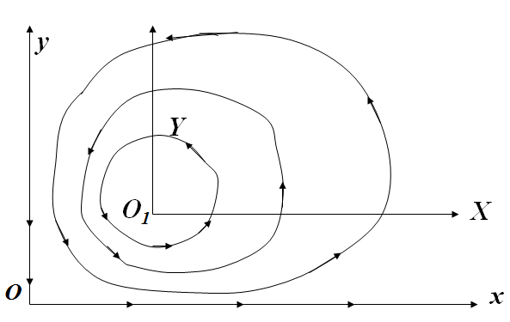
Figure 31. Phase portrait of the system “predator – prey”
The matrix $\left[\begin{matrix}0 & {−\text{bc}}/d \\ {\text{ad}}/b & 0\end{matrix}\right]$ has the purely imaginary eigenvalues $λ_{1}=i\sqrt{\text{ac}}$, $λ_{1}=−i\sqrt{\text{ac}}$. So the point O₁ (c/d, a/b) is a center for the linear system (7.6). In order to answer whether the point O₁ (c/d, a/b) to be a center for the original non-linear system (7.1) we’ll consider a function $K(x,y)=x^{c}e^{−\text{dx}}y^{a}e^{−\text{by}}$. This function has its maximum in the point (c/d, a/b). On the other hand this function is a constant of motion for the system (7.1), that is $K(x(t),y(t))=\text{const}, \text{if} (x(t), y(t))$ any solution of the system (7.1). So its level curves, where $K(x,y)=\text{const},$ are closed trajectories of the system (7.1), surrounding the point O₁ (c/d, a/b).
Let us draw the graphs of the functions $x(t)$ and $y(t)$.

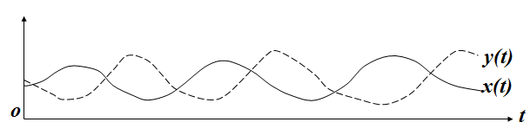
Figure 32. Oscillations of the quantities of predators and prays
As you can see periodical oscillations of the quantity $y(t)$ of predators are performed with a delay about ¼ of the period with respect to the quantity $x(t)$ of preys. It’s interesting to note that some similar graphs of quantities of foxes and hares in Canada had been published in 1903 after natural observations.

7.2. A model of a competing coexistence of two populations
A model for two competing populations may be described by the following differential equations:
$$x^{'}=a_{\text{11}}x−a_{\text{12}}x^{2}−a_{\text{13}}\text{xy},$$
$y^{'}=a_{\text{21}}y−a_{\text{22}}y^{2}−a_{\text{23}}\text{xy}\text{.}$ (7.7)
The coefficients $a_{\text{11}}$ and $a_{\text{21}}$ determine the intensities of reproduction, the coefficients $a_{\text{12}}$ and $a_{\text{22}}$ determine the intensities of internal competitions, the coefficients $a_{\text{13}}$ and $a_{\text{23}}$ determine the intensities of external competitions. Unfortunately this model depends on many parameters. There is a method to reduce the number of parameters by replacing the variables: $x=({a_{\text{11}}}/{a_{\text{12}}})u, y=({a_{\text{21}}}/{a_{\text{22}}})v \text{and} t=τ/{a_{\text{11}}}\text{.}$ After this replacing the system (7.7) will accept the form:
$$u^{'}=u−u^{2}−ε_{1}\text{uv},$$
$v^{'}=δ(v−v^{2}−ε_{2}\text{uv}),$ (7.8)
where $ε_{1}=a_{\text{21}}{a_{\text{13}}}/{a_{\text{11}}}a_{\text{22}} \text{and} ε_{2}=a_{\text{11}}{a_{\text{23}}}/{a_{\text{21}}}a_{\text{12}}\text{.}$
This system has four points of equilibrium: (0,0), (1,0), (0,1) and $((1−ε_{1})/(1−ε_{1},ε_{2}), (1−ε_{2})/(1−ε_{1},ε_{2}))\text{.}$
For every point of equilibrium we’ll consider a correspondent linear system. For the point (0,0) the linear system will be the following:
$$u^{'}=u,$$
$v^{'}=δv\text{.}$ (7.9)
It’s not difficult to find the eigenvalues $λ_{1}=1, λ_{2}=δ$.
It means that this point will be an unstable node.
To find the linear system for the point (1,0) we’ll change the variable $u=U+1,$ so the value U will be an infinitesimal in a small neighborhood of this point.
After this change we’ll receive the system:
$$U^{'}=U+1−(U+1)^{2}−ε_{1}(U+1)v,$$
$$v^{'}=δ(v−v^{2}−ε_{2}(U+1)v)\text{.}$$
Its linear part will be
$$U^{'}=−U−ε_{1}v,$$
$v^{'}=δ(1−ε_{2})v\text{.}$ (7.10)
The eigenvalues are $λ_{1}=−1, λ_{2}=δ(1−ε_{2})v\text{.}$
To find the linear system for the point (0,1) we’ll change the variable $v=V+1,$ so the value V will be an infinitesimal in a small neighborhood of this point.
After this change we’ll receive the system:
$$u^{'}=u−u^{2}−ε_{1}u(V+1),$$
$$V^{'}=δ(V+1−(V+1)^{2}−ε_{2}u(V+1))\text{.}$$
Its linear part will be
$$u^{'}=(1−ε_{1})u,$$
$V^{'}=−{\text{δε}}_{2}u−δV\text{.}$ (7.11)
The eigenvalues are $λ_{1}=1−ε_{1}, λ_{2}=−δ\text{.}$
In order to find the linear system for the next point $((1−ε_{1})/(1−ε_{1}ε_{2}), (1−ε_{2})/(1−ε_{1}ε_{2}))$ we’ll change the variables $u=U+(1−ε_{1})/(1−ε_{1}ε_{2}), v=V+(1−ε_{2})/(1−ε_{1}ε_{2}),$ so the values U and V will be infinitesimals in a small neighborhood of this point. After this change we’ll receive the system:
$$U^{'}=U+1−(U+1)^{2}−ε_{1}(U+1)(V+1),$$
$$V^{'}=δ(V+1−(V+1)^{2}−ε_{2}(U+1)(V+1))\text{.}$$
Its linear part will be the following:
$$U^{'}=−((1−ε_{1})/(1−ε_{1}ε_{2}))U−(ε_{1}(1−ε_{2})/(1−ε_{1}ε_{2}))V,$$
$V^{'}=−({\text{δε}}_{2}(1−ε_{1})/(1−ε_{1}ε_{2}))U−(δ(1−ε_{2})/(1−ε_{1}ε_{2}))V\text{.}$
The equation for the eigenvalues is the following:
$λ^{2}+Aλ+B=0,$ (7.12)
where $A=\left[(1−ε_{1})/(1−ε_{1}ε_{2})+(1−ε_{2})/(1−ε_{1}ε_{2})\right], B=δ(1−ε_{1})(1−ε_{2})/(1−ε_{1}ε_{2})\text{.}$

1. Let us consider the case when $0<ε_{1}<1, 0<ε_{2}<1\text{.}$
For this case the point (1,0) will be a saddle, the point (0,1) will be a saddle too. The point $((1−ε_{1})/(1−ε_{1}ε_{2}), (1−ε_{2})/(1−ε_{1}ε_{2}))$ will be a stable node, because for this case the coefficients A and B in the equation (7.12) will be positive (see the Figure 33).
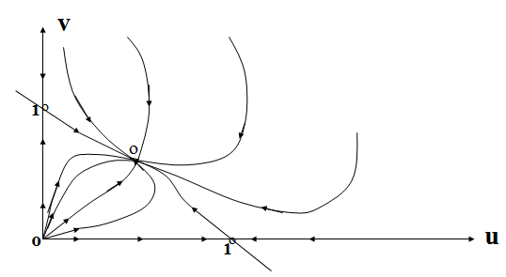
Figure 33. Phase portrait for the case
2. Let us consider the case when $ε_{1}>1, ε_{2}>1\text{.}$
For this case the points (1,0) and (0,1) will be stable nodes, and the point $((1−ε_{1})/(1−ε_{1}ε_{2}), (1−ε_{2})/(1−ε_{1}ε_{2}))$ will be a saddle, because for this case the coefficient A in the equation (7.12) will be positive and the coefficient B will be negative. The phase space is divided in two parts by the $ω$-separatrices of the saddle, so that all the trajectories in the first part go to the point (1,0) and in the second part to the point (0,1).
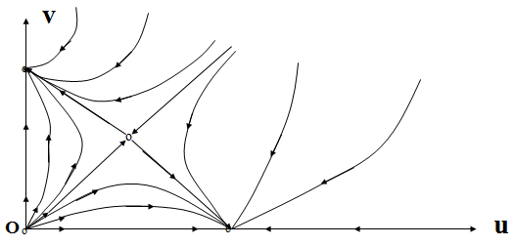
Figure 34. Phase portrait for the case $ε_{1}>1, ε_{2}>1$
3. Let us consider the case when $ε_{1}>1, 0<ε_{2}<1$
For this case the point (1,0) will be a saddle, the point (0,1) will be a stable node, and the point $((1−ε_{1})/(1−ε_{1}ε_{2}), (1−ε_{2})/(1−ε_{1}ε_{2}))$ will not be situated at the phase space.
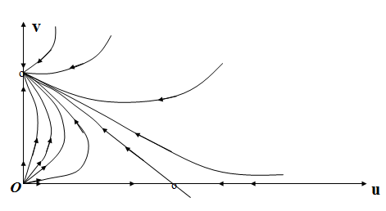
Figure 34. Phase portrait for the case $ε_{1}>1, 0<ε_{2}<1$
4. Let us consider the case when $0<ε_{1}<1, ε_{2}>1$
For this case the point (1,0) will be a stable node, the point (0,1) will be a saddle, and the point $((1−ε_{1})/(1−ε_{1}ε_{2}), (1−ε_{2})/(1−ε_{1}ε_{2}))$ will not be situated at the phase space.
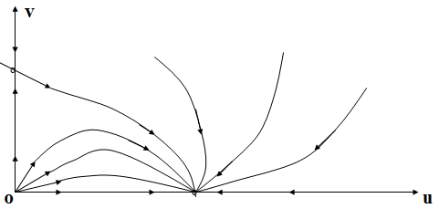
Figure 35. Phase portrait for the case $0<ε_{1}<1, ε_{2}>1$
So we may sum up the results of the investigation in the following form: there are four domains $D_{i}$ in the parametric plane $(ε_{1},ε_{2})$ with different kinds of relations between these two populations.
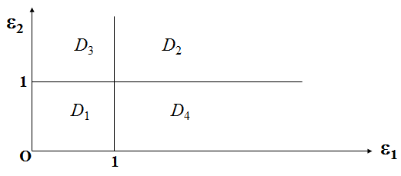
Figure 36. Four domains with different phase portraits
In the domain D₁ these relations really allow them to coexist peacefully. In the domain D₂ the external competing is very high, so only one of them may exist. In the domain D₃ (D₄) the population u (v) is more strong and aggressive and this population wins.

8. Some gravitational models
Let us consider some problems concerned with the development of cosmic investigations such as a problem of soft landing and problems of movement of material bodies in the Earth’s gravitational field.
8.1. A movement of a missile in the cosmic space
Tsiolkovsky K. was the first who has proved the possibility for missiles to reach any arbitrary velocity. This possibility was the applying of a missile jet engine, ejecting a gas jet in the direction being reverse to that of the missile movement. Let the missile of the mass m have the velocity V and the ejected mass move with the velocity c, produced by the burnt propellant of the missile.
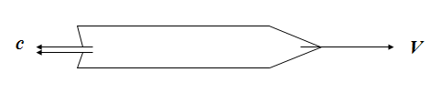
Figure 37. Movement of a missile in the cosmic space
We suppose the missile being moving in a cosmic space without of any external forces. In this case the second law of Newton will be as follows:
$(\text{mV})^{'}=0,$ (8.1)
that is the momentum $K=\text{mV}$ will be a constant. Let us calculate the momentum K for the same mass m for two instants t and $t+Δt$. For the instant t we have $K(t)=m(t)V(t)$. At the instant $t+Δt$ we have the mass $m(t)=m(t+Δt)+(−Δm)$, where the mass $(−Δm)$ was ejected out of the missile. The velocity of the missile will be equal to $V(t+Δt)=V(t)+ΔV$.
So the value of the momentum $K(t+Δt)$ for the initial mass m(t) will be equal to $K(t+Δt)=m(t+Δt)V(t+Δt)+(−Δm)(V(t)+c)$.
Applying the property of momentum conservation mentioned above we’ll receive:
$\begin{aligned}m(t+Δt)V(t+Δt)+(−Δm)(V(t)+c)=m(t)V(t), \\ (m(t)+Δm)(V(t)+ΔV)−Δm(V(t)+c)=m(t)V(t), \\ m(t)ΔV+ΔmΔV=Δ\text{mc}\text{.}\end{aligned}$
Projecting the last equation to the direction of missile’s movement we’ll receive:
$$m(t)ΔV+ΔmΔV=−Δ\text{mc}\text{.}$$
Dividing the last equation by $ΔV$ tending to zero we’ll have
${\text{dm}}/{\text{dV}}=−(1/c)m\text{.}$ (8.2)
The general solution of the equation (8.2) has the form:
$$m=A\text{exp}(−V/c)\text{.}$$
If the initial values of m and V are equal to m₀ and 0 respectively, then we’ll have the partial solution
$m=m_{0}\text{exp}(−V/c)\text{.}$ (8.3)
The graph of the dependence (8.3) is shown below.
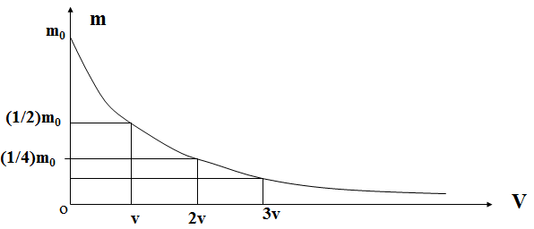
Figure 38. Decreasing of the missile’s mass with increasing of missile’s speed
We see that when the velocity V is increasing as an arithmetic progression with a difference $V=c\text{ln}2$, the mass m will decrease in accordance with a geometrical progression having the common ratio 1/2! The modern jet engines may eject the fuel with the velocity c about 2 km/s. For this case the value of the difference V will be equal to 1.4 km/s. It’s not difficult to calculate that when the missile achieves the final velocity V = 8km/s (the first cosmic velocity) its mass will be equal to ${m_{0}}/{\text{64}}$ (see the table 1).
Table 1. Dependence of the missile’s speed on its final mass
$$m_{0}$$ | $${m_{0}}/2$$ | $${m_{0}}/4$$ | $${m_{0}}/8$$ | $${m_{0}}/{\text{16}}$$ | $${m_{0}}/{\text{32}}$$ | $${m_{0}}/{\text{64}}$$
0 | 1.4 | 2.8 | 4.2 | 5.6 | 7.0 | 8.4

8.2. A flight of a projectile
Let us consider a flight of a projectile having the initial velocity $V_{0}$ and the angle $ϕ$ to the horizon. We are interested in the time T of this flight and its range D.
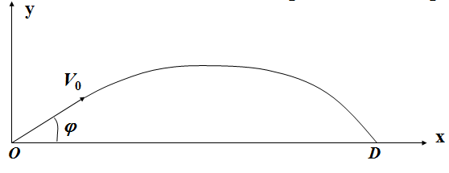
Figure 39. A trajectory of a projectile
The equation of the flight may be written as follows:
$\text{ma}=\text{mg}+F_{r},$ (8.4)
where $F_{r}$ is the force of resistance of the atmosphere.
This force is usually supposed to be equal to $−αV$.
So the equation (8.4) accepts the form
$\text{ma}=\text{mg}−αV\text{.}$ (8.5)
Projecting this equation to the axes x and y respectively we’ll receive the system
$${\text{mx}}^{\text{\} \} = - αx rSup \{ size 8\{'\} \} ,\} \{}}$$
${\text{my}}^{\text{\} \} = - ital }mg\text{ - αy rSup \{ size 8\{'\} \} \} \{}}$ (8.6)
with the initial conditions $x(0)=0,x^{'}(0)=V_{0}\text{cos}ϕ,$ and $y(0)=0,y^{'}(0)=V_{0}\text{sin}ϕ\text{.}$
The solution of the first equation with the given initial conditions will be equal to $x(t)=(m/α)V_{0}\text{cos}ϕ(1−\text{exp}(−{αt}/m))\text{.}$
The solution of the second equation with the given initial conditions will be equal to $y(t)=(m/α)(({\text{mg}}/α)+V_{0}\text{sin}ϕ)(1−\text{exp}(−{αt}/m))−{\text{mgt}}/α\text{.}$
The time T of the flight may be found if we can solve the equation:
$$(m/α)(({\text{mg}}/α)+V_{0}\text{sin}ϕ)(1−\text{exp}(−{αT}/m))−{\text{mgT}}/α=0\text{.}$$
But this equation is so-called transcendental one, so we’ll try to solve it using the following approximation:
$$\text{exp}(−{αT}/m)≃1−{αT}/m+α^{2}{T^{2}}/2m^{2}\text{.}$$
With this approximation the time T of the flight will be equal to
$T=2V_{0}\text{sin}ϕ/(g+(α/m)V_{0}\text{sin}ϕ)$ (8.7)
and the range (the flight distance) will be equal to
$D=V_{0}^{2}g\text{sin}2ϕ/(g+(α/m)V_{0}\text{sin}ϕ)^{2}\text{.}$ (8.8)
It’s interesting to note that for the case $α=0$ we’ll have the exact formula
$$T=2V_{0}\text{sin}ϕ/g,$$
$$D=V_{0}^{2}\text{sin}2ϕ/g\text{.}$$
From the second formula we see that the range will be the largest with the angle $ϕ=π/4\text{.}$
To answer the same question for the case $α>0$ it’s necessary to derivate the function $D(ϕ)$:
$$D_{ϕ}^{'}=2{\text{gV}}_{0}^{2}(g(1−2{\text{sin}}^{2}ϕ)−(α/m)V_{0}\text{sin}ϕ)/(g+(α/m)V_{0}\text{sin}ϕ)^{3}\text{.}$$
Solving the equation $2g{\text{sin}}^{2}ϕ+(α/m)V_{0}\text{sin}ϕ−g=0$, we’ll find: $\text{sin}ϕ=\left[−(α/m)V_{0}+\sqrt{({{αV}_{0}}/m)^{2}+8g^{2}}\right]4g\text{.}$
It’s not difficult to verify that $\text{sin}ϕ<(\sqrt{2})/2, \text{so} ϕ<π/4\text{.}$

8.3. A problem of two bodies
Let us consider a movement of a satellite around the Earth. In accordance with the law of gravitation the equation of its movement has the form
${\text{mr}}^{\text{\} \} = - \backslash ( ital }GmM\text{/r rSup \{ size 8\{3\} \} \backslash ) r,\} \{}}$ (8.9)
where M and m are the masses of the Earth and the satellite respectively, r and $r^{\text{\} \} \} \{}}$ are vectors describing satellite’s state and acceleration, G is the universal constant. Using the equation (8.9) we’ll try to find some equations (in a polar system of coordinates), that we may solve.
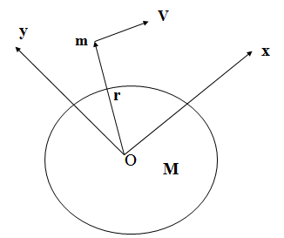
Figure 40. Movement of a satellite around the Earth
The first step will be the following: we’ll consider the vector product of the vector r and the equation (8.9).
Because $r×r=0$, we’ll have $r×r^{\text{\} \} =0\} \{}}$. The last equality we may write in the form $(r×r^{'})^{'}=0$, so we receive
$(r×r^{'})=a\text{.}$ (8.10)
As $r=x(t)i+y(t)j+0k, r^{'}=x^{'}(t)i+y(t)j+0k$, the equality (8.10) may be written in the form:
$0i+0j+(x(t)y^{'}(t)−x^{'}(t)y(t))k=a\text{.}$ (8.11)
The equation (8.11) may be written in a scalar form:
$x(t)y^{'}(t)−x^{'}(t)y(t)=a\text{.}$ (8.12)
Using the polar system of coordinates ($r,ϕ$) with $x=r\text{cos}ϕ, y=r\text{sin}ϕ$ the equation (8.12) may be written in the form
$$r\text{cos}ϕ(r^{'}\text{sin}ϕ+r\text{cos}{\text{ϕϕ}}^{'})−r\text{sin}ϕ(r^{'}\text{cos}ϕ+r\text{sin}{\text{ϕϕ}}^{'})=a,$$
and after some simple transformations we’ll receive very attractive equation
$r^{2}ϕ^{'}=a\text{.}$ (8.13)
The second step consists of scalar multiplication of the equation (8.9) by the vector $r^{'}$:
$$(r^{'},r^{\text{\} \} \backslash ) = - \backslash ( ital }GM\text{/r rSup \{ size 8\{3\} \} \backslash ) \backslash ( r,r rSup \{ size 8\{}})\text{.}$$
The equation above may be written in the form
$((r^{'}{)^{2}}/2)^{'}=−({\text{GM}}/{r^{3}})(({r^{2}}/2)^{'}$,
and after some simple transformations we’ll receive:
$$((r^{'}{)^{2}}/2−{\text{GM}}/r)^{'}=0\text{.}$$
The equation above means that $(r^{'})^{2}−2{\text{GM}}/r=b$ (a constant).
Since $(r^{'})^{2}=(x^{'})^{2}+(y^{'})^{2}=(r^{'}\text{cos}ϕ−r\text{sin}{\text{ϕϕ}}^{'})^{2}+(r^{'}\text{sin}ϕ+r\text{cos}{\text{ϕϕ}}^{'})^{2}$, the last equation accepts the form $(r^{'})^{2}+r^{2}(ϕ^{'})^{2}−2{\text{GM}}/r=b\text{.}$
Using the equation (8.13) we’ll receive the equation for $r^{'}$:
$r^{'}=±\sqrt{b+2{\text{GM}}/r−{a^{2}}/{r^{2}}}\text{.}$ (8.14)
Instead of the system of the equation (8.13), (8.14) it’s more comfortable to have the only equation
${\text{dr}}/{dϕ}=±({r^{2}}/a)\sqrt{b+2{\text{GM}}/r−{a^{2}}/{r^{2}}}\text{.}$ (8.15)
Introducing the new function $u=1/r$ we’ll receive $−({\text{du}}/{dϕ}=±(1/a)\sqrt{b+2\text{GMu}−a^{2}u^{2}}\text{.}$
The last equation we’ll derivate
$$−d^{2}u/{dϕ}^{2}=±\left[\left(\text{GM}−a^{2}u\right)/\left(a\sqrt{b+2\text{GMu}−a^{2}u^{2}}\right)\right]\text{du}/dϕ,$$
and using the expression for ${\text{du}}/{dϕ}$ we’ll receive: $d^{2}u/{{dϕ}^{2}}+u={\text{GM}}/{a^{2}}\text{.}$
This simple linear equation has the following solution:
$$u=C_{1}\text{cos}ϕ+C_{2}\text{sin}ϕ+{\text{GM}}/{a^{2}}\text{.}$$
And finally we have found the family of the trajectories of the satellite:
$r=({a^{2}}/{\text{GM}})/(1+c_{1}\text{cos}ϕ+c_{2}\text{sin}ϕ),$ (8.16)
where the constants $c_{1}$ and $c_{2}$ are determined by the initial conditions (that is the state and the velocity of the satellite at the initial moment of time).
What kind of curves does the equation (8.16) describe?
At first we may note that for the values $c_{1}=c_{2}=0$ this equation means the circle.
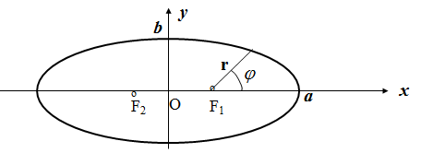
Figure 41. Graph of an ellipse
May be for the values of these constants close to zero we’ll receive an ellipse?
The equation of an ellipse is ${x^{2}}/{a^{2}}+{y^{2}}/{b^{2}}=1\text{.}$ Let us write the equation of an ellipse in a polar system, having $x=c+r\text{cos}ϕ, y=r\text{sin}ϕ,$ where $c^{2}=a^{2}−b^{2}$, and the constant $ε=c/a$ to be called the eccentric of the ellipse. The equation of the ellipse accepts the following form:
$(c+r\text{cos}ϕ{)^{2}}/{a^{2}}+(r\text{sin}ϕ{)^{2}}/{b^{2}}=1$,
$({\text{cos}}^{2}ϕ/{a^{2}}+{\text{sin}}^{2}ϕ/{b^{2}})r^{2}+(2c\text{cos}ϕ/{a^{2}})r−{b^{2}}/{a^{2}}=0\text{.}$ (8.17)
Let us simplify the first coefficient:
$$\begin{aligned}{\text{cos}}^{2}ϕ/{a^{2}}+{\text{sin}}^{2}ϕ/{b^{2}}={\text{cos}}^{2}ϕ/{a^{2}}+(1−{\text{cos}}^{2}ϕ)/{b^{2}}= \\ (1/{a^{2}}−1/{b^{2}}){\text{cos}}^{2}ϕ+1/{b^{2}}=1/{b^{2}}−({c^{2}}/{a^{2}}b^{2}){\text{cos}}^{2}ϕ= \\ (1/{b^{2}})(1−ε^{2}{\text{cos}}^{2}ϕ)\text{.}\end{aligned}$$
The positive solution of this quadratic equation will be
$$r=(−2c\text{cos}ϕ/{a^{2}}+2/a)/(1/{b^{2}})(1−ε^{2}{\text{cos}}^{2}ϕ),$$
or $r=(2{b^{2}}/a)/(1+ε\text{cos}ϕ)\text{.}$ It is the particular case of the formula (8.16) when $c_{2}=0$ and $c_{1}=ε$.
The other particular case of this equation may be a parabola $y^{2}=2\text{px}$. With the given values $\text{KO}=\text{OF}=p/2$ in a polar system we’ll have
$x=(p/2)+r\text{cos}ϕ, y=r\text{sin}ϕ,$ and $(r\text{sin}ϕ)^{2}=2p\left[(p/2)+r\text{cos}ϕ\right]=p^{2}+2\text{pr}\text{cos}ϕ),$ or $(\text{sin}ϕ)^{2}r^{2}−(2p\text{cos}ϕ)r−p^{2}=0\text{.}$
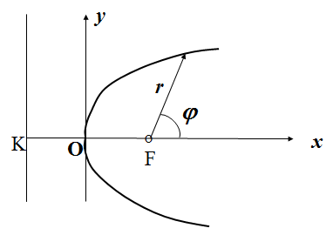
Figure 42. Graph of a parabola
One of the solutions of this quadratic equation is
$r=(2p\text{cos}ϕ+\sqrt{(2p\text{cos}ϕ)^{2}+4p^{2}{\text{sin}}^{2}ϕ)}/2{\text{sin}}^{2}ϕ,$ or
$r=p(1+\text{cos}ϕ)/(1−{\text{cos}}^{2}ϕ)=p/(1+\text{cos}ϕ)\text{.}$
Here we see one curve out of the family of the trajectories (8.16).
And now let us consider the equation of hyperbola ${x^{2}}/{a^{2}}−{y^{2}}/{b^{2}}=1$ in a polar system.
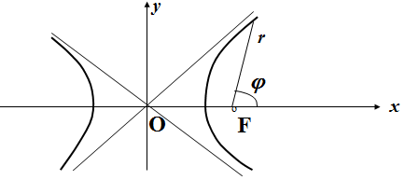
Figure 43. Graph of a hyperbola
The distance $\text{OF}=c$, and $c^{2}=b^{2}+a^{2}\text{.}$ Introducing the polar coordinates $x=c+r\text{cos}ϕ, y=r\text{sin}ϕ$ we’ll receive $(c+r\text{cos}ϕ{)^{2}}/{a^{2}}−(r\text{sin}ϕ{)^{2}}/{b^{2}}=1\text{.}$ For the value r we obtain the quadratic equation
$$({\text{cos}}^{2}ϕ/{a^{2}}−{\text{sin}}^{2}ϕ/{b^{2}})+(2c\text{cos}ϕ/{a^{2}})r−{b^{2}}/{a^{2}}=0\text{.}$$
Before to find the solution it will be more useful to simplify the expression ${\text{cos}}^{2}ϕ/{a^{2}}−{\text{sin}}^{2}ϕ/{b^{2}}=(1/{a^{2}}+1/{b^{2}}){\text{cos}}^{2}ϕ−1/{b^{2}}=−(1/{b^{2}})(1−({c^{2}}/{a^{2}}){\text{cos}}^{2}ϕ\text{.}$
So we’ll have one of the roots
$$r=(−2c\text{cos}ϕ/{a^{2}}−2/a)/{−(}1/{b^{2}})(1−({c^{2}}/{a^{2}}){\text{cos}}^{2}ϕ),$$
or $r=(2{b^{2}}/a)/(1−ε\text{cos} ϕ),$ that is one of the family of the trajectories (8.16).

9. Dynamical models for rational behaviour
9.1 Automata models for rational behaviour
In this lecture we’ll begin to study some dynamical models of rational behaviour, games and teaching. The development of these problems started in the 60-th years of the last century and it was accompanied with a well-known public discussion on the subject “Is a computer able to think?” One party asserted a computer to be capable of thinking as far as it is able to solve complicated mathematical problems, can play chess and control a nuclear reactor, can “read” a draught and so on. The opposite party objected and stated that a computer is incapable of thinking, but only able to perform ordered actions. This dispute seems senseless until there will be made an agreement on what “thinking” is.
What does “a thinking” differ from the execution of some program of actions in? It’s hardly possible now to give a profound answer to this question, because we in fact know almost nothing about how our brain is functioning. But there are some simple automata models of rational behaviour, that may be perceived as some elements of thinking. Let us start from describing an automata model for behaviour of a rat choosing between two feeding troughs as shown in the figure below.
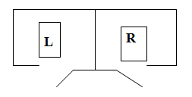
Figure 44. The scheme of the experiment with a rat
This experiment was used to investigate learning capabilities of rats. Food was placed from time to time into one trough (with the probability p) or another (with the probability $q=1−p$) and the rat ate the food or remained hungry till the other time. After some time of this experiment the rat began to choose the trough where the food was placed with the greater probability! We’ll construct an automaton with four states: $A_{−2}, A_{−1},A_{1},A_{2}$. Its output y is equal to $−1 \text{for} A_{−2}, A_{−1}$ and $+1 \text{for} A_{1},A_{2}$.
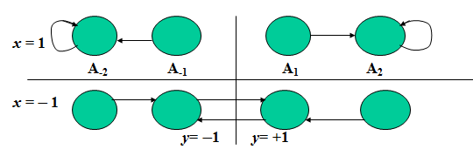
Figure 45. The change of states with inputs $x=1$ and $x=−1$
The graph of state changes depend on the input to the automaton as it is represented in the figure above.
The input $x=1$ means a stimulation of the automaton (in the case of the rat it receives a food), the input $x=−1$ means a penalty (the rat does not receive a food). Let p and $q=1−p$ be the probabilities of placement of food to the left trough and to the right trough respectively. So our automaton becomes a stochastic automaton with the graph of states which are changing as it is shown below.
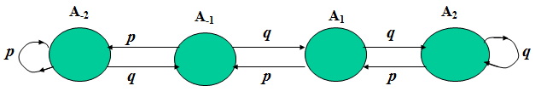
Figure 46. The scheme of a stochastic automaton with a memory equal to 2
It is evident the states $A_{−2}, A_{−1},A_{1},A_{2}$ of the automaton cannot be the states of a dynamical system, because the knowledge of the state at the previous moment of time is not sufficient to predict its state at the next moment of time. However the probabilities of these states may be predicted. This situation brings us to the idea that these probabilities may be employed as the states of a new kind of dynamical systems – stochastic dynamical systems. Let $p_{−2}(n), p_{−1}(n),p_{1}(n),p_{2}(n)$ be the probabilities of staying of the automaton at the states $A_{−2}, A_{−1},A_{1},A_{2}$ respectively for the moment n. So we can find these probabilities for the moment $n+1$:
$$p_{−2}(n+1)={\text{pp}}_{−2}(n)+{\text{pp}}_{−1}(n),$$
$$p_{−1}(n+1)={\text{qp}}_{−2}(n)+{\text{pp}}_{−1}(n),$$
$$p_{1}(n+1)={\text{qp}}_{−1}(n)+{\text{pp}}_{2}(n),$$
$p_{2}(n+1)={\text{qp}}_{1}(n)+{\text{qp}}_{2}(n)\text{.}$ (9.1)
This system may be written in the vector form
$p(n+1)=p(n)P,$ (9.2)
where $P=(p_{\text{ij}})$ is so-called stochastic matrix. All elements of this matrix are non-negative and the sum of all elements in every row is equal to 1. All the eigen- values $λ_{i}$ of a stochastic matrix are restricted $−1≤λ_{i}≤1$, and at least one of them is equal to 1. The equation (9.2) describes so-called a markovian process, or a process of Markov. It may be written also in the form
$p(n)=p(0)P^{n}\text{.}$ (9.3)
There is a very important class of the markovian processes that are called ergodic processes. This class is determined by the following property $\text{lim}p(n)=p,$ for $n→∞$.
The limit vector p is called the vector of final probabilities.
There exists a sufficient condition to determine when a markovian process will be an ergodic process. If there exists any m such that the matrix $P^{m}$ consists of only positive numbers then this markovian process will be an ergodic process. In our case the matrix P is determined by the equations (9.1):
$$P=\left[\begin{matrix}p & q & 0 & 0 \\ p & 0 & q & 0 \\ 0 & p & 0 & q \\ 0 & 0 & p & q\end{matrix}\right] P^{2}=\left[\begin{matrix}p & \text{pq} & q^{2} & 0 \\ p^{2} & 2\text{pq} & 0 & q^{2} \\ p^{2} & 0 & 2\text{pq} & q^{2} \\ 0 & p^{2} & \text{pq} & q\end{matrix}\right]$$
$$P^{4}=\left[\begin{matrix}p^{2}(1+q+q^{2}) & p^{2}q(1+2q) & {\text{pq}}^{2}(1+2q) & q^{3} \\ p^{2}(1+q) & p^{2}q(1+4q) & {\text{pq}}^{2} & q^{3}(1+2p) \\ p^{3}(1+2q) & p^{2}q & {\text{pq}}^{2}(1+4q) & q^{3}(1+2p) \\ p^{3}(1+q) & p^{2}q(1+2p) & {\text{pq}}^{2}(1+2p) & q^{2}(1+p)\end{matrix}\right]$$
So we see that our markovian process satisfies the sufficient condition hence it is an ergodic process.
We are allowed to find the vector p of final probabilities using the limit equation received from (9.2):
$p=\text{pP}, \text{or} p(E−P)=0\text{.}$ (9.4)
Taking into account that the determinant of the matrix $(E−P)$ is equal to zero and the system (9.4) has infinite set of solutions we complete this system by the following evident equation
$p_{−2}+p_{−1}+p_{1}+p_{2}=1\text{.}$ (9.5)
So we have the system:
$\begin{aligned}p_{−2}={\text{pp}}_{−2}+{\text{pp}}_{−1} \\ p_{−1}={\text{qp}}_{−2}+{\text{pp}}_{−1} \\ p_{1}={\text{qp}}_{−1}+{\text{pp}}_{2} \\ p_{−2}+p_{−1}+p_{1}+p_{2}=1\text{.}\end{aligned}$ (9.6)
This system has the following solution: $p_{−2}={p^{3}}/(p^{2}+q^{2}),$
$p_{−1}=p^{2}q/(p^{2}+q^{2}), p_{1}={{\text{pq}}^{2}}/(p^{2}+q^{2}), p_{2}={q^{3}}/(p^{2}+q^{2})\text{.}$
It means that our automaton “will choose” the left trough with the probability $p(y=−1)=p_{−2}+p_{−1}={p^{2}}/(p^{2}+q^{2})$, and the right trough with the probability $p(y=1)=p_{1}+p_{2}={q^{2}}/(p^{2}+q^{2})$. For example, if $p=0\text{.}6$ and $q=0\text{.}4$ then $p(y=−1)=0\text{.}\text{69}$ and $p(y=1)=0\text{.}\text{31}$.
So we may say that this automaton has some rational behaviour! It must be pointed out that this automaton has a depth of the memory equal to two. It’s possible to investigate the behaviour of an automaton with a depth of the memory equal to three. In this case we’ll receive $p(y=−1)=0\text{.}\text{78}$ and $p(y=1)=0\text{.}\text{22}$.

9.2. A problem of pursuit
There are two objects: one of them is running away and the other will be pursuing. These objects are supposed to have some equal possibilities: every next time they may stay at the same place or go only to the neighbour place. The places of the disposition of these objects form a circle with 6 places as it is shown below.
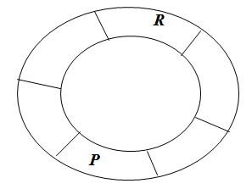
Figure 47. The scheme of a pursuit
We denote by the symbol R the running out object and by the symbol P the pursuing object. The object R has a stochastic behaviour: it goes on (to the direction of hour-hand) with the probability p, stays at the same place with the probability q and goes back (to the reverse direction of hour-hand) with the probability r.
The object P may choose depending on their mutual disposition one of the strategies at every time: or the strategy 1 (to go on), or the strategy 2 (to stay at the same place), or the strategy 3 (to go back). In order to construct a stochastic dynamical system it’s necessary at first to determine the states of this system and in particular the number of these states. The simple reasoning give us the number 36: 6 states for the object R and for every state of R the object P has 6 states! But their disposition on the circle gives us the possibility to reduce the number of the states.
Indeed, the mutual disposition will be different only for the following cases; the objects P and R are staying at the same place (it does not matter at what place of the given 6 places), or P is situated ahead of R for one place, or two, or three, or four, or five places. So we have only 6 states of their mutual disposition and 6 states $p_{1}(n), p_{2}(n), p_{3}(n), p_{4}(n), p_{5}(n), p_{6}(n)$ of the dynamical system. Now we have to determine the operator of transference (displacement) of the system from one state to another. It will be possible if we determine the strategy of the object P for every its state. It seems reasonable to determine this strategy by the following vector (2, 3, 3, 3, 1, 1), that means the strategy number 2 for the state corresponding to the disposition of the objects at the same place, the strategy number 3 for the state corresponding to the disposition of the object P ahead of R for one place, and so on. For this strategy the operator of transference of this stochastic dynamical system will be represented by the following equations:
$$p_{1}(n+1)={\text{qp}}_{1}(n)+{\text{qp}}_{2}(n)+{\text{pp}}_{3}(n)+{\text{rp}}_{5}(n)+{\text{qp}}_{6}(n),$$
$$p_{2}(n+1)={\text{rp}}_{1}(n)+{\text{rp}}_{2}(n)+{\text{qp}}_{3}(n)+{\text{pp}}_{4}(n)+{\text{rp}}_{6}(n),$$
$$p_{3}(n+1)={\text{rp}}_{3}(n)+{\text{qp}}_{4}(n),$$
$$p_{4}(n+1)={\text{rp}}_{4}(n),$$
$$p_{5}(n+1)={\text{pp}}_{5}(n),$$
$$p_{6}(n+1)={\text{pp}}_{1}(n)+{\text{pp}}_{2}(n)+{\text{qp}}_{5}(n)+{\text{pp}}_{6}(n)\text{.}$$
Let $p=1/2, q=1/4, r=1/4$. We suppose the markovian process to be ergodic. So the system of equations for the vector of final probabilities will be the following:
$$p_{1}=1/4p_{1}+1/4p_{2}+1/2p_{3}+1/4p_{5}+1/4p_{6},$$
$$p_{2}=1/4p_{1}+1/4p_{2}+1/4p_{3}+1/2p_{4}+1/4p_{6},$$
$$p_{3}=1/4p_{3}+1/4p_{4},$$
$$p_{4}=1/4p_{4},$$
$$p_{5}=1/2p_{5},$$
$$p_{1}+p_{2}+p_{3}+p_{4}+p_{5}+p_{6}=1\text{.}$$
It’s clear that $p_{3}=p_{4}=p_{5}=0$. The other probabilities will be equal to $p_{1}=1/4, p_{2}=1/4, p_{6}=1/2\text{.}$ So the average value of the distance D between P and R will be equal to $D={0×1}/4+{1×1}/4+{1×1}/2=3/4\text{.}$

10. Stochastic dynamical systems with incomes
Now we’ll consider some discrete markovian processes accompanied some incomes (or some expenses). For example [2] an artisan produces some handicraft wares and goes to the market having the purpose to sell them.
The result is supposed to be different: the state 1 means the artisan sells all his handicraft wares and has an income, the state 2 means the artisan does not sell his handicraft wares and has an expense. It depends may be on the result this artisan had the previous time. Let $p_{\text{ij}}$ be the conditional probabilities to pass to the state j from the state i, and $p(n)=(p_{1}(n), p_{2}(n))$ be the vector of the probabilities to be in the states 1 and 2 at the moment of time n.
So we’ll have the following stochastic model
$p(n+1)=p(n)P, \text{or} p(n)=p(0)P^{n}$, (10.1)
where P is a stochastic matrix ($p_{\text{ij}}$).
Example 1. Let the matrix $P=\left[\begin{matrix}0\text{.}5 & 0\text{.}5 \\ 0\text{.}4 & 0\text{.}6\end{matrix}\right]$. So we’ll have the homogenous system of linear equations in differences:
$\begin{aligned}p_{1}(n+1)=0\text{.}5p_{1}(n)+0\text{.}4p_{2}(n), \\ p_{2}(n+1)=0\text{.}5p_{1}(n)+0\text{.}6p_{2}(n)\text{.}\end{aligned}$ (10.2)
The theory of linear systems in differences is very similar to the theory of linear systems of differential equations. Let us try to find the general solution of the system (10.2) in the form $p_{1}(n)=A(α)^{n}, p_{2}(n)=B(α)^{n}\text{.}$
In this way we’ll receive the following algebraic system:
$\begin{aligned}(α−0\text{.}5)A−0\text{.}4B=0 \\ −0\text{.}5A+(α−0\text{.}6)B=0\end{aligned}$ (10.3)
To find a non-trivial solution it’s necessary the determinant of this system be equal to zero, so we have the equation for $α$:
$α^{2}−1\text{.}1α+0\text{.}1=0\text{.}$ (10.4)
One of the eigenvalues of the matrix P is equal to 1, and another is equal to 0.1. For the value 1 we’ll find the eigenvector $(A, B)=(1, 1\text{.}\text{25})$. For the value 0.1 we’ll find the eigenvector $(A, B)=(1, −1)$. So we have two particular solutions of the system (10.2), forming its general solution:
$$p_{1}(n)=C_{1}(1)^{n}+C_{2}(0\text{.}1)^{n}, p_{2}(n)=C_{1}1\text{.}\text{25}(1)^{n}−C_{2}(0\text{.}1)^{n}\text{.}$$
So far as $p_{1}(n)+p_{2}(n)=1$ we’ll have $C_{1}=4/9$, and
$$p_{1}(n)=4/9+C_{2}(0\text{.}1)^{n}, p_{2}(n)=5/9−C_{2}(0\text{.}1)^{n}\text{.}$$
We see that this markovian process is ergodic. The vector of final probabilities is equal to (4/9, 5/9).
The constant $C_{2}$ may be found with the given initial vector $p(0)=(p_{1}(0), p_{2}(0))\text{.}$
Now let us describe the financial side of the above process. Let the elements of the matrix $D=(d_{\text{ij}})$ be the values of income corresponding every pass from the state i to the state j. For example:
$$D=\left[\begin{matrix}9 & 3 \\ 3 & −7\end{matrix}\right]$$
To construct a mathematical model describing the change of the financial state of our artisan we’ll introduce the following functions:
Let $V_{1}(n) (V_{2}(n))$ be a mathematical expectation of the total income after n steps of the markovian process, if its initial condition had been 1 (2). The matrices P and D give us the possibility to find the state $(V_{1}(n+1), V_{2}(n+1))$ if we know the state $(V_{1}(n), V_{2}(n))$. Indeed,
$\begin{aligned}V_{1}(n+1)=p_{\text{11}}(d_{\text{11}}+V_{1}(n))+p_{\text{12}}(d_{\text{12}}+V_{2}(n)), \\ V_{2}(n+1)=p_{\text{21}}(d_{\text{21}}+V_{1}(n))+p_{\text{22}}(d_{\text{22}}+V_{2}(n))\text{.}\end{aligned}$ (10.5)
We’ll denote the mathematical expectation of the income after one step from the state 1 as $q_{1}=p_{\text{11}}d_{\text{11}}+p_{\text{12}}d_{\text{12}}$, and the mathematical expectation of the income after one step from the state 2 as $q_{2}=p_{\text{21}}d_{\text{21}}+p_{\text{22}}d_{\text{22}}\text{.}$ Let V(n) be the vector-column $(V_{1}(n),V_{2}(n))^{T}$, then the system (10.5) may be written in the form:
$V(n+1)=\text{PV}(n)+Q,$ (10.6)
where Q is the vector-column $(q_{1}, q_{2})^{T}\text{.}$ It is a linear non-homogenous system of the equations in differences. The general solution of this system consists of the general solution of the corresponding homogenous system and any particular solution of the non-homogenous system. For our case of the above artisan we’ll have the system:
$\begin{aligned}V_{1}(n+1)=0\text{.}5V_{1}(n)+0\text{.}5V_{2}(n)+6, \\ V_{2}(n+1)=0\text{.}4V_{1}(n)+0\text{.}6V_{2}(n)−3\text{.}\end{aligned}$ (10.7)
The general solution of the homogenous system will be equal to
$$\begin{aligned}V_{1}(n)=C_{1}+C_{2}(0\text{.}1)^{n}, \\ V_{2}(n)=C_{1}−0\text{.}8C_{2}(0\text{.}1)^{n}\text{.}\end{aligned}$$
Some particular solution of the system (10.7) we’ll find in the form $V_{1}(n)=\text{an}+b, V_{2}(n)=\text{cn}+d\text{.}$ The constants $a, b, c, d$ may be found from the following equalities, which are held for any natural n:
$$a(n+1)+b=0\text{.}5(\text{an}+b)+0\text{.}5(\text{cn}+d)+6,$$
$$c(n+1)+d=0\text{.}4(\text{an}+b)+0\text{.}6(\text{cn}+d)−3\text{.}$$
Solving the linear algebraic system $a=0\text{.}5a+0\text{.}5c, a+b=0\text{.}5b+0\text{.}5d+6,$ $c=0\text{.}4a+0\text{.}6c, c+d=0\text{.}4b+0\text{.}6d−3,$ we’ll receive $a=c=1,$ and $b=d+\text{10}\text{.}$
So we’ll have the general solution of the system (10.7):
$$\begin{aligned}V_{1}(n)=C_{1}+C_{2}(0\text{.}1)^{n}+n+\text{10}, \\ V_{2}(n)=C_{1}−0\text{.}8C_{2}(0\text{.}1)^{n}+n\text{.}\end{aligned}$$
With the initial conditions $V_{1}(0)=V_{2}(0)=0$ we’ll have
$$\begin{aligned}V_{1}(n)=n+{\text{50}}/9−(0\text{.}1)^{n}{\text{50}}/9, \\ V_{2}(n)=n−{\text{40}}/9+(0\text{.}1)^{n}{\text{40}}/9\text{.}\end{aligned}$$
We see that the total incomes will increase by 1 unit after each step no matter what the initial state was, but the total income V₁(n) will be more by 10 units than V₂(n) (see the figure 48).
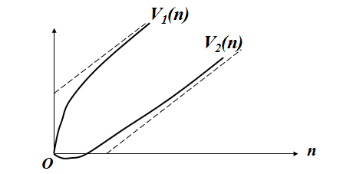
Figure 48. Increasing of total incomes

11. The choice of optimal strategy
11.1 Optimal strategy for a finite process
Method of R. Bellman
Let be given some number of stochastic matrices $P^{(k)}, k=\vec{1, K},$ and corresponding them matrices of incomes $D^{(k)}\text{.}$ For every state $i, i=\vec{1, m}$ we can choose the number $k_{i},$ forming a vector $s=(k_{1}, k_{2},…k_{m}),$ that we’ll name as a strategy. We may choose one of them having the purpose to receive the most possible income as a result of the performing of the corresponding markovian process. Let $V_{i}(n)$ be the maximum of the mathematical expectation of the income after n steps provided the initial state was i. To receive the equation for these functions we’ll use the principle of optimality of R. Bellman [3]. It asserts: for any way to be optimal it’s necessary and sufficient to be optimal any rest of this way.
As a result of this principle we’ll have the equation:
$V_{i}(n+1)=\text{max}\left\{\sum{{}^{m}}p_{\text{is}}^{(k)}\left(d_{\text{is}}^{(k)}+V_{s}(n)\right)\right\}, i=\vec{1, m}$ (11.1)

Example 1. Let an artisan producing and selling his handicraft wares be able to choose one of the three following marcovian processes with incomes:
1) $P^{(1)}=\begin{matrix}0\text{.}5 & 0\text{.}5 \\ 0\text{.}4 & 0\text{.}6\end{matrix} D^{(1)}=\begin{matrix}9 & 3 \\ 3 & −7\end{matrix}$,
2) $P^{(2)}=\begin{matrix}0\text{.}6 & 0\text{.}4 \\ 0\text{.}5 & 0\text{.}5\end{matrix} D^{(2)}=\begin{matrix}8 & 2 \\ 2 & −8\end{matrix}$,
3) $P^{(3)}=\begin{matrix}0\text{.}7 & 0\text{.}3 \\ 0\text{.}6 & 0\text{.}4\end{matrix} D^{(1)}=\begin{matrix}6 & 0 \\ 0 & −\text{10}\end{matrix}$.
It corresponds for example the cases when: 1) the artisan doesn’t use any advertisement, 2) he uses an advertisement in newspapers, 3) he uses an advertisement by TV.
We’ll begin the solution of the equation (11.1) with the following initial conditions $V_{1}(0)= V_{2}(2)=0\text{.}$
$$V_{1}(1)= \text{max} \begin{matrix}0\text{.}5×9+0\text{.}5×3=6, \\ 0\text{.}6×8+0\text{.}4×2=5\text{.}6, \\ 0\text{.}7×6+0\text{.}3×0=4\text{.}2\text{.}\end{matrix}$$
So we have $k_{1}(1)=1, V_{1}(1)=6\text{.}$
$$V_{2}(1)= \text{max} \begin{matrix}0\text{.}4×3+0\text{.}6×(−7)=−3, \\ 0\text{.}5×2+0\text{.}5×(−8)=−3, \\ 0\text{.}6×0+0\text{.}4×(−\text{10})=−4\text{.}\end{matrix}$$
So we have $k_{2}(1)=1, V_{1}(1)=−3\text{.}$
Having the values $V_{1}(1)=6$ and $V_{2}(1)=−3$ we pass to the process with two steps:
$$V_{1}(1)= \text{max} \begin{matrix}6+0\text{.}5×6+0\text{.}5×(−3)=7\text{.}5, \\ 5\text{.}6+0\text{.}6×6+0\text{.}4×(−8)=8, \\ 4\text{.}2+0\text{.}7×6+0\text{.}3×(−3)=7\text{.}5\text{.}\end{matrix}$$
So we have $k_{1}(2)=2, V_{1}(2)=8\text{.}$
$$V_{2}(1)= \text{max} \begin{matrix}−3+0\text{.}4×6+0\text{.}6×(−3)=−2\text{.}4, \\ −3+0\text{.}5×6+0\text{.}5×(−3)=−1\text{.}5, \\ −4+0\text{.}6×6+0\text{.}4×(−3)=−1\text{.}6\text{.}\end{matrix}$$
So we have $k_{1}(2)=2, V_{2}(2)=−1\text{.}5\text{.}$
It means that the second strategy will be the optimal strategy for the first step if the process having two steps.
Having the values $V_{1}(2)=8$ and $V_{2}(2)=−1\text{.}5$ we pass to the process with three steps:
$$V_{1}(1)= \text{max} \begin{matrix}6+0\text{.}5×8+0\text{.}5×(−1\text{.}5)=9\text{.}\text{25}, \\ 5\text{.}6+0\text{.}6×8+0\text{.}4×(−1\text{.}5)=9\text{.}8, \\ 4\text{.}2+0\text{.}7×8+0\text{.}3×(−1\text{.}5)=9\text{.}\text{35}\text{.}\end{matrix}$$
So we have $k_{1}(3)=2, V_{1}(3)=9\text{.}8\text{.}$
$$V_{2}(1)= \text{max} \begin{matrix}−3+0\text{.}4×8+0\text{.}6×(−1\text{.}5)=−0\text{.}7, \\ −3+0\text{.}5×8+0\text{.}5×(−1\text{.}5)=0\text{.}\text{25}, \\ −4+0\text{.}6×8+0\text{.}4×(−1\text{.}5)=0\text{.}2\text{.}\end{matrix}$$
So we have $k_{2}(3)=2, V_{2}(3)=0\text{.}\text{25}\text{.}$
It means that the second strategy will be the optimal strategy for the first step if the process has three steps.
It seems that with grow of steps the optimal strategy to become stationary. How to find it? Namely how to find the optimal strategy provided the number of steps is infinite.

11.2. Optimal strategy for an infinite process
Method of R. Howard
The answer to this question was given by R. Howard in 1960. He noted that the values $V_{i}(n)$ have the following asymptotic form:
$V_{i}(n)=\text{gn}+V_{i}$. (11.2)
Using this asymptotic form for the mathematical expectations $V_{i}(n)$ he proposed an iterative procedure to find the stationary optimal strategy. This procedure consists of two blocks: “the block of solutions” where we have to solve a linear algebraic system with respect to the values g and $V_{i}$, and “the block of optimization” where we produce an improvement of the precedent strategy. The linear algebraic system we receive from the equations (11.1) with a fixed strategy (that is without of the procedure max):
$g(n+1)+V_{i}=\sum{{}^{m}}p_{\text{is}}\left(d_{\text{is}}+\text{gn}+V_{s}\right)\text{.}$ (11.3)
Let us denote the mathematical expectation of the income after one step from the state i as $q_{i}=\sum{{}^{m}}p_{\text{is}}d_{\text{is}}\text{.}$ After that we’ll note that $\sum{p_{\text{is}}(\text{gn})=\text{gn}},$ because $\sum{p_{\text{is}}=1\text{.}}$ So we’ll receive the required system:
$g+V_{i}=q_{i}+\sum{{}^{m}}p_{\text{is}}V_{s}, i=\vec{1,m}\text{.}$ (11.4)
It’s necessary to note that we have m equations and $m+1$ unknowns: g and $V_{i}, i=\vec{1, m}$. To choose only one of the infinite number of solutions we’ll prove that with any solution g and $V_{i}, i=\vec{1, m}$, of the system (11.4) the set g and $V_{i}+a, i=\vec{1, m}$, will be also the solution of (11.4) for any a! Indeed, adding to the both parts of the equation (11.4) the constant a we’ll receive
$$g+V_{i}+a=q_{i}+\sum{{}^{m}}p_{\text{is}}V_{s}+a=q_{i}+\sum{{}^{m}}p_{\text{is}}(V_{s}+a), i=\vec{1, m}\text{.}$$
So let us suppose that $a=−V_{m},$ and the solution of the system (11.4) accept the form: $g, V_{1}, V_{2}, … V_{m−1}, 0\text{.}$
Now let us describe the block of optimization using the equation (11.1) and the asymptotic form (11.2) for $V_{i}(n)\text{.}$
$$V_{i}(n)=\text{max}\left\{\sum{{}^{m}}p_{\text{is}}^{(k)}\left(d_{\text{is}}^{(k)}+\text{gn}+V_{s}^{(k)}\right)\right\}=\text{max}\left\{q_{i}^{(k)}+\sum{{}^{m}}p_{\text{is}}^{(k)}V_{s}^{(k)}\right\}, i=\vec{1,m}\text{.}$$
So the algorithm of R. Howard may be represented by the following way.
1) For some strategy $A=(k_{1}, k_{2}, …, k_{m})$ we find the solution of the given above form $g, V_{1}, V_{2}, … V_{m−1}, 0$ of the linear system
$$g+V_{i}=q_{i}+\sum{{}^{m}}p_{\text{is}}V_{s}, i=\vec{1, m}\text{.}$$
This solution we use in the block of optimization :
2) $\underset{k}{\text{max}}\left\{q_{i}^{(k)}+\sum{{}^{m}}p_{\text{is}}^{(k)}×V_{s}\right\}, i=\vec{1,m}\text{.}$
After this block we’ll have a new strategy $B=(l_{1}, l_{2}, …, l_{m})\text{.}$
If the new strategy B coincides with the preceding strategy A the iterative process will be over. If the new strategy B doesn’t coincide with the preceding strategy A the iterative process will be continue.
Theorem 1. If the strategy B is an improvement of the preceding strategy A by Howard’s iteration, then the strategy B is better than the strategy A, that is $g^{(B)}≥g^{(A)}\text{.}$
The proof. For the strategies B and A we’ll have in the block of optimization:
$$q_{i}^{(B)}+\sum{{}^{m}}p_{\text{is}}^{(B)}V_{s}≥q_{i}^{(A)}+\sum{{}^{m}}p_{\text{is}}^{(A)}V_{s}, \text{for} i=\vec{1, m}\text{.}$$
Let us denote $γ_{i}=q_{i}^{(B)}−q_{i}^{(A)}+\sum{{}^{m}}\left(p_{\text{is}}^{(B)}−p_{\text{is}}^{(A)}\right) V_{s}\text{.}$
It’s evident that $γ_{i}≥0\text{.}$
As for the block of solutions we’ll have for the strategies A and B the following systems:
$g^{(A)}+V_{i}^{(A)}=q_{i}^{(A)}+\sum{{}^{m}}p_{\text{is}}^{(A)}V_{s}^{(A)}, i=\vec{1, m},$ (11.5)
$g^{(B)}+V_{i}^{(B)}=q_{i}^{(B)}+\sum{{}^{m}}p_{\text{is}}^{(B)}V_{s}^{(B)}, i=\vec{1, m}\text{.}$ (11.6)
Subtracting (11.5) from (11.6) and using the value $γ_{i}$ we’ll have for all $i=1, m\text{.}$
$$g^{(B)}−g^{(A)}+V_{i}^{(B)}−V_{i}^{(A)}=q_{i}^{(B)}−q_{i}^{(A)}+γ_{i}+\sum{{}^{m}}p_{\text{is}}^{(B)}\left(V_{s}^{(B)}−V_{s}^{(A)}\right)\text{.}$$
Let $p=(p_{1}, p_{2}, …, p_{m})$ be the vector of final probabilities for the markovian process corresponding to the strategy B, that is $p={\text{pP}}^{(B)}\text{.}$ Multiplying the preceding relations by the values $p_{i}$ and summarize them we’ll receive:
$$g^{(B)}−g^{(A)}+\sum{{}^{m}}p_{i}\left(V_{i}^{(B)}−V_{i}^{(A)}\right)=\sum{{}^{m}}p_{i}γ_{i}+\sum{\sum{p_{i}}}p_{\text{is}}^{(B)}\left(V_{s}^{(B)}−V_{s}^{(A)}\right)\text{.}$$
But $\sum{{}^{m}}p_{i}p_{\text{is}}^{(B)}=p_{s}^{(B)},$ so we’ll receive:
$g^{(B)}−g^{(A)}=\sum{{}^{m}}p_{i}γ_{i}≥0\text{.}$ (11.7)
The theorem 1 is proved.
Theorem 2. If the strategy A has no improvement by Howard’s iteration, then any strategy B is not better than the strategy A, that is $g^{(B)}≤g^{(A)}\text{.}$

Example 2. Let us apply the iterative method of Howard to the problem of the artisan having the purpose to find optimal stationary strategy for the infinite number of steps. Let (1, 1) be an initial strategy.
The block of the solutions (taking into account that $V_{2}=0$) will be presented by the system
$$g+V_{1}=6+0\text{.}5V_{1},$$
$$g=−3+0\text{.}4V_{1}\text{.}$$
The solution of this system is $V_{1}=\text{10}, (V_{2}=0), g=1\text{.}$
Now let us realize the calculations in the block of optimization :
1) $\text{max} \text{of}: \begin{matrix}6+0\text{.}5×\text{10}=\text{11}, \\ 5\text{.}6+0\text{.}6×\text{10}=\text{11}\text{.}6, \\ 4\text{.}2+0\text{.}7×\text{10}=\text{11}\text{.}2\text{.}\end{matrix}$
2) $\text{max} \text{of}: \begin{matrix}−3+0\text{.}4×\text{10}=1, \\ −3+0\text{.}5×\text{10}=2, \\ −4+0\text{.}6×\text{10}=2\text{.}\end{matrix}$
As a result of this block we have $k_{1}=2 \text{and} k_{2}=2$ (or 3).
So far as the new strategy (2, 2) doesn’t coincide with the initial strategy (1, 1), we pass to the block of the solutions for the new strategy:
$$g+V_{1}=5\text{.}6+0\text{.}6V_{1},$$
$$g=−3+0\text{.}5V_{1}\text{.}$$
It’s easy to find the solution: $V_{1}={\text{86}}/9 (V_{2}=0), g={\text{16}}/9\text{.}$ We see that for the new strategy (2, 2) the incomes are growing faster than for the strategy (1, 1). The second time we go to the block of optimization:
1) $\text{max} \text{of}: \begin{matrix}6+0\text{.}{5×\text{86}}/9={\text{97}}/9, \\ 5\text{.}6+0\text{.}{6×\text{86}}/9={\text{102}}/9, \\ 4\text{.}2+0\text{.}{7×\text{86}}/9={\text{98}}/9\text{.}\end{matrix}$
2) $\text{max} \text{of}: \begin{matrix}−3+0\text{.}{4×\text{86}}/9={\text{37}}/{\text{45}}, \\ −3+0\text{.}{5×\text{86}}/9={\text{80}}/{\text{45}}, \\ −4+0\text{.}{6×\text{86}}/9={\text{78}}/{\text{45}}\text{.}\end{matrix}$
As a result of this block we have $k_{1}=2 \text{and} k_{2}=2$. It means that the optimal strategy will be (2, 2).

12. Optimization. A model of optimal rhythmical production
Let $p_{i}, i=\vec{1, n}$, be daily deliveries of raw material used in some production. There exists a storehouse for this raw material with given maximum daily volumes $V_{i}, i=\vec{1, n}\text{.}$
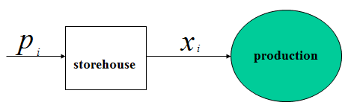
Figure 49. The scheme of a production
So the used daily quantities of this raw material used in the production must satisfy the following inequalities
$0≤\sum_{i=1}^{i=k}{p_{i}−}\sum_{i=1}^{i=k}{x_{i}}≤V_{k}, k=\vec{1, n}\text{.}$ (12.1)
Denoting $B_{k}=\sum_{i=1}^{i=k}{p_{i}, }A_{k}=\sum_{i=1}^{i=k}{p_{i}−}V_{k}$we may write the inequalities (12.1) in the following comfortable form
$A_{k}≤\sum_{i=1}^{i=k}{x_{i}}≤B_{k}, k=\vec{1, n}\text{.}$ (12.2)
Let $P=\sum_{i=1}^{i=n}{x_{i}}$ be the plan of work for the given period. It is known for any production to be rhythmical is desirable. But the ideal rhythmical plan $X^{i}=\left(\frac{P}{n},…,\frac{P}{n}\right)$may be impermissible if it doesn’t satisfy at least one of the restrictions (12.2) (due to irregular daily deliveries of raw material). So we come to the problem of optimization: it’s necessary to find such a vector that would be the most close to the ideal vector $X^{i}\text{.}$
As a criterion of the fact how close is a vector $X$ to the ideal vector $X^{i}$ we may choose the value of the following function: $F(X)=\sum_{i=1}^{i=n}{{ \left(x_{i}−\frac{B_{n}}{n}\right)}^{2}}\text{.}$
The problem 1. It’s necessary to find a vector $X^{0}$ in the set D
$D=\left\{X∈R_{n}|A_{k}≤\sum_{i=1}^{i=k}{x_{i}}≤B_{k}, A_{k}≤B_{k}, k=\vec{1, n−1,} \sum_{i=1}^{i=n}{x_{i}=P}\right\}$ such that $F(X^{0})=\text{min}F(X)$ for every $X∈D\text{.}$
The existence of such vector is evident, because the function $F(X)$ is continuous and the set D is limited and closed. It is a standard problem of mathematical programming. The main result of this theory is given by the theorem of Kuhn–Tuсker [4]. Let us apply this theorem to our problem. The function of Lagrange for our problem has the following form:
$$L=F(X)+\sum_{k=1}^{k=n−1}{λ_{i}\left(\sum_{i=1}^{i=k}{x_{i}}−B_{k}\right)+\sum_{k=1}^{k=n−1}{γ_{i}\left(A_{k}−\sum_{i=1}^{i=k}{x_{i}}\right)+}}ρ\left(\sum_{i=1}^{i=n}{x_{i}}−P\right)$$
Let $X^{0}$ be optimal vector, then there exist nonnegative vectors $λ=(λ_{1}, λ_{2}, …,λ_{n−1}), γ=(γ_{1}, γ_{2},…, γ_{n−1}),$ and a factor of Lagrange $ρ$ such that the following conditions are held:
1) $\frac{∂L(X^{0},λ,γ,ρ)}{∂x_{i}}=0, i=\vec{1, n},$
2) $\sum_{i=1}^{i=k}{x_{i}^{0}}−B_{k}≤0, A_{k}−\sum_{i=1}^{i=k}{x_{i}^{0}}≤0, k=\vec{1, n−1}, \sum_{i=1}^{i=n}{x_{i}^{0}}−P=0,$
3) $λ_{k}\left(\sum_{i=1}^{i=k}{x_{i}^{0}}−B_{k}\right)=0, γ_{k}\left(A_{k}−\sum_{i=1}^{i=k}{x_{i}^{0}}\right)=0, k=\vec{1, n−1}\text{.}$
The key to the application of this theorem stays in the conditions 3). For every number $k$ we must choose either $λ_{k}>0(γ_{k}>0)$ and $\sum_{i=1}^{i=k}{x_{i}^{0}}=B_{k}\left(A_{k}=\sum_{i=1}^{i=k}{x_{i}^{0}}\right),$ or $\sum_{i=1}^{i=k}{x_{i}^{0}}−B_{k}<0, \left(A_{k}−\sum_{i=1}^{i=k}{x_{i}^{0}}<0\right)$ and $λ_{k}=0(γ_{k}=0)$.
In the first case the restriction $\sum_{i=1}^{i=k}{x_{i}}−B_{k}≤0 \left(A_{k}−\sum_{i=1}^{i=k}{x_{i}}≤0\right)$ is called “essential restriction”. In the second case this restriction is not essential. So the system (12.1)–(12.3) is actually a set of $2^{2n−2}$ systems, and only one of them gives the solution of the problem. We’ll try to find some more effective necessary (and sufficient) conditions of optimality using all the special features of the problem. These conditions will give us the possibility to determine what restrictions will be essential [5].
Theorem 1. Vector $X^{0}∈D$ is optimal for the problem 1 if and only if every two its components $x_{k}^{0}$ and $x_{j}^{0}(k>j)$ are satisfying one of the following conditions:
a) $x_{k}^{0}=x_{j}^{0};$
b) $x_{k}^{0}<x_{j}^{0},$ then there exists a number $m∈\left\{j, j+1,…, k−1\right\}$ such that $\sum_{i=1}^{i=m}{x_{i}^{0}}=B_{m};$
c) $x_{k}^{0}>x_{j}^{0},$ then there exists a number $m∈\left\{j, j+1,…, k−1\right\}$ such that $\sum_{i=1}^{i=m}{x_{i}^{0}}=A_{m}\text{.}$
N. Let $X^{0}∈D$ be an optimal vector, not satisfying any of the conditions a), b), c). So there exists a pair of its components $x_{j}^{0}$ and $x_{j}^{0}(k>j)$ such that $x_{k}^{0}$ is not equal to $x_{j}^{0}$ and if $x_{k}^{0}>x_{j}^{0},$, then $\sum_{i=1}^{i=m}{x_{i}^{0}}<B_{m}$ for every $m∈\left\{j, j+1,…, k−1\right\}$. Let us construct an auxiliary vector $X(δ)=(x_{1}^{0},…, x_{j}^{0}+δ,…, x_{k}^{0}−δ, x_{n}^{0})\text{.}$ This vector with a positive and sufficiently small $δ$ will be permissible, that is $X^{0}∈D$. Сalculation of the difference $ΔF=F(X(δ))−F(X^{0})$ gives us the following result: $ΔF=−2δ(x_{k}^{0}−x_{j}^{0}−δ)\text{.}$ Taking into account that $δ$ is positive and sufficiently small $(δ<x_{k}^{0}−x_{j}^{0}),$ we’ll receive the contradiction to the fact that $X^{0}$ is optimal vector. By the same way we can prove the necessity of the condition c).
S. Let $X^{0}∈D$ be a vector satisfying all conditions a), b), c), and $Y^{0}∈D$ be an optimal vector. We’ll try to prove that these vectors coincide. Indeed, let $x_{1}^{0}=y_{1}^{0}, x_{2}^{0}=y_{2}^{0},…, x_{j−1}^{0}=y_{j−1}^{0},$ but $x_{j}^{0}>y_{j}^{0}$ (the case $x_{j}^{0}<y_{j}^{0}$ may be proved by the same way).
So far as $\sum_{i=1}^{i=n}{x_{i}^{0}}=\sum_{i=1}^{i=n}{y_{i}^{0}=}P$ there will exist a number $k>j$ such that for every $m∈\left\{j, j+1,…, k−1\right\}$ we’ll have the inequalities
$\sum_{i=1}^{i=m}{x_{i}^{0}}>\sum_{i=1}^{i=m}{y_{i}^{0},}$ (12.3)
but $\sum_{i=1}^{i=k}{x_{i}^{0}}≤\sum_{i=1}^{i=k}{y_{i}^{0}\text{.}}$ That means that $x_{k}^{0}<y_{k}^{0}\text{.}$
Let us suppose that $x_{k}^{0}≥x_{j}^{0}\text{.}$ Then we’ll have $y_{k}^{0}>x_{k}^{0}≥x_{j}^{0}>y_{j}^{0}\text{.}$ As the vector $Y^{0}$ is optimal it must satisfy the condition b). Namely there exist a number $m∈\left\{j, j+1,…, k−1\right\}$ such that $\sum_{i=1}^{i=m}{y_{i}^{0}=B_{m}\text{.}}$ But taking into account the inequalities (12.3) we’ll have the inequality $\sum_{i=1}^{i=m}{x_{i}^{0}>B_{m},}$ which is impossible for the vector $X^{0}$, because $X^{0}∈D$.
Let us suppose that $x_{k}^{0}<x_{j}^{0}\text{.}$ Then there exist a number $m∈\left\{j, j+1,…, k−1\right\}$ such that $\sum_{i=1}^{i=m}{x_{i}^{0}=A_{m}}$. But taking into account the inequalities (12.3) in this case we’ll have $\sum_{i=1}^{i=m}{y_{i}^{0}<A_{m},}$ that is impossible for the vector $Y^{0}$. Thus our supposition that there exist a number j such that $x_{j}^{0}>y_{j}^{0}$, (or $x_{j}^{0}<y_{j}^{0}$) involves the contradictions with the given assumptions of the theorem 1.
Remark. The proof of the theorem shows that the assertions of this theorem will be just not only for the function $F(X)=\sum_{i=1}^{i=n}{{\left(x_{i}−\frac{B_{n}}{n}\right)}^{2},}$ but for any convex function $G(X)=\sum_{i=1}^{i=n}{f(x_{i}), f^{\text{\} \} \} \backslash ( x rSub \{ size 8\{i\} \} \backslash ) >0,\} \{}}}$ as well.
Corollary 1. Let $X^{0}$ be an optimal vector, then:
A) if $\sum_{i=1}^{i=m}{x_{i}^{0}<B_{m},}$ then $x_{m}^{0}≥x_{m+1}^{0};$
B) if $\sum_{i=1}^{i=m}{x_{i}^{0}>A_{m},}$ then $x_{m}^{0}≤x_{m+1}^{0}\text{.}$
Corollary 2. If vector $X^{0}∈D$ is optimal for the problem 1 then every two its components $x_{k}^{0}$ and $x_{k+1}^{0}$ are satisfying one of the following conditions:
a) $x_{k}^{0}=x_{k+1}^{0}$;
b) $x_{k}^{0}<x_{k+1}^{0}$, and $\sum_{i=1}^{i=k}{x_{i}^{0}=B_{k}}$;
c) $x_{k}^{0}>x_{k+1}^{0}$, and $\sum_{i=1}^{i=k}{x_{i}^{0}=A_{k}}$.
Theorem 2. Let $α_{i}=B_{i}−i\frac{P}{n}, β_{i}=i\frac{P}{n}−A_{i}\text{.}$ Then:
a) if $α_{i}≥0, β_{i}≥0,$ the vector $X^{i}=\left(\frac{P}{n}, \frac{P}{n},…, \frac{P}{n}\right)$will be optimal;
b) if $α_{k}=\text{min}α_{i}<0,$ then the restriction $\sum_{i=1}^{i=k}{x_{i}≤B_{k}}$ will be essential, that is $\sum_{i=1}^{i=k}{x_{i}^{0}=B_{k}}$;
c) if $β_{k}=\text{min}β_{i}<0,$, then the restriction $\sum_{i=1}^{i=k}{x_{i}≥A_{k}}$ will be essential, that is $\sum_{i=1}^{i=k}{x_{i}^{0}=A_{k}}$.
The proof. The assertion a) is evident, because the vector $X^{i}$ will be permissible and its optimality is involved by the theorem 1.
The assertion b) we’ll try to prove by the method of receiving contradictions.
Let us suppose $α_{k}=\text{min}α_{i}<0,$ but $\sum_{i=1}^{i=k}{x_{i}^{0}=C_{k}<B_{k}}$.
From the corollary of the theorem 1 we have $x_{k}^{0}≥x_{k+1}^{0}$.
The value of $x_{k}^{0}$ may be less than $\frac{P}{n}$ or not. Let us consider the first alternative. In the first case we’ll have $x_{k+1}^{0}≤x_{k}^{0}<\frac{P}{n}\text{.}$ As $α_{k}=B_{k}−k\frac{P}{n}<0,$ then $\sum_{i=k+1}^{i=n}{x_{i}^{0}=P−C_{k}>P−B_{k}>P−k\frac{P}{n}=(n−k)\frac{P}{n}\text{.}}$
That means that there exists a component $x_{j}^{0}$ such that $x_{k+1}^{0}<\frac{P}{n}, x_{k+2}^{0}<\frac{P}{n},…, x_{j−1}^{0}<\frac{P}{n},$ but $x_{j}^{0}>\frac{P}{n}\text{.}$ So we have $x_{j}^{0}>x_{k}^{0}(j>k)\text{.}$ In accordance with the theorem 1 there exists a number $m∈\left\{j, j+1,…, k−1\right\}$ such that $\sum_{i=1}^{i=m}{x_{i}^{0}=B_{m}\text{.}}$ Let us calculate the difference $α_{m}−α_{k}$:
$$α_{m}−α_{k}=\left(B_{m}−m\frac{P}{n}\right)−\left(B_{k}−k\frac{P}{n}\right)<(B_{m}−C_{k})−(m−k)\frac{P}{n}=\sum_{i=k+1}^{i=m}{x_{i}^{0}−}(m−k)\frac{P}{n}<0\text{.}$$
This inequality contradicts to the choice of $α_{k}$. Let us consider the second alternative, when $x_{k}^{0}≥\frac{P}{n}\text{.}$ As $α_{k }=B_{k}−k\frac{P}{n}<0,$ then $\sum_{i=1}^{i=k}{x_{i}^{0}=C_{k}<B_{k}}<k\frac{P}{n}\text{.}$ It means that there exists a number j such that $x_{k}^{0}≥\frac{P}{n}, x_{k−1}^{0}≥\frac{P}{n},…, x_{j+1}^{0}≥\frac{P}{n},$ but $x_{j}^{0}<\frac{P}{n}\text{.}$
According to the theorem 1 there exists a number $m∈\left\{j, j+1,…, k−1\right\}$ such that $\sum_{i=1}^{i=m}{x_{i}^{0}=B_{m}\text{.}}$
Let us calculate the difference $α_{m}−α_{k}$:
$$α_{m}−α_{k}=\left(B_{m}−m\frac{P}{n}\right)−\left(B_{k}−k\frac{P}{n}\right)<(k−m)\frac{P}{n}−(C_{k}− B_{m})=(k−m)\frac{P}{n}−\sum_{i=m+1}^{i=k}{x_{i}^{0}}≤0\text{.}$$
This inequality contradicts to the choice of the value $α_{k}$. So the assertion b) is proved. The assertion c) may be proved by the same way.
Application of the theorem 2.
The theorem 2 gives us an effective method to find the optimal vector. Let us illustrate this method solving a concrete problem.
Let the set D be given by the following restrictions $A_{j}≤\sum_{i=1}^{i=j}{x_{i}≤B_{j},} j=\vec{1, \text{12}},$ where the values of $A_{j}$ and $B_{j}$ are represented below in the table:
j: | 1 | 2 | 3 | 4 | 5 | 6 | 7 | 8 | 9 | 10 | 11 | 12
$$A_{j}$$ | 1 | 3 | 5 | 8 | 10 | 16 | 22 | 27 | 39 | 45 | 51 | 58
$$B_{j}$$ | 6 | 8 | 10 | 13 | 15 | 21 | 27 | 32 | 44 | 50 | 58 | 63
Let P = 60 be the plan of production for 12 days.
So the average value $\frac{P}{n}$ will be equal to 5. The values $α_{j}$ and $β_{j}$ are represented in the table below
j: | 1 | 2 | 3 | 4 | 5 | 6 | 7 | 8 | 9 | 10 | 11 | 12
$$α_{j}$$ | 1 | −2 | −5 | −7 | −10 | −9 | −8 | −8 | −1 | 0 | 3 | 3
$$β_{j}$$ | 4 | 7 | 10 | 12 | 15 | 14 | 13 | 13 | 6 | 5 | 4 | 2
We find $α_{5}=\text{min}α_{j}<0\text{.}$ So the restriction $\sum_{i=1}^{i=5}{x_{i}≤B_{5}}$ must be essential, that is $\sum_{i=1}^{i=5}{x_{i}=B_{5}}$. The initial problem of optimization to find the minimum value of the convex function $G(X)=\sum_{i=1}^{i=\text{12}}{f(x_{i})}$ in the set D we can now to split into two sub-problems of optimization of the same kind but with the less dimensions!
Sub-problem 1: find the minimum value of the convex function $G(X_{1})=\sum_{i=1}^{i=5}{f(x_{i})}$ in the set $D_{1}=\left\{X_{1}∈R_{5}:A_{j}≤\sum_{i=1}^{i=j}{x_{i}≤B_{j}, j=\vec{1, 4}}, \sum_{i=1}^{i=5}{x_{i}=B_{5}}\right\}\text{.}$ We have now the average value $\frac{B_{5}}{5}=3\text{.}$ The values $α_{j}$, $β_{j}$ are represented in the table below:
j: | 1 | 2 | 3 | 4 | 5
$$α_{j}$$ | 3 | 2 | 1 | 1 | 0
$$β_{j}$$ | 2 | 3 | 4 | 4 | 5
All the values $α_{j}$, $β_{j}$ are non-negative , so we have the optimal vector for the sub-problem 1: $X_{1}^{0}=(3, 3, 3, 3, 3)\text{.}$
Sub-problem 2: find the minimum value of the convex function $G(X_{2})=\sum_{i=1}^{i=7}{f(x_{i})}$ in the set
$$D_{2}=\left\{X_{2}∈R_{7}:a_{j}≤\sum_{i=1}^{i=j}{x_{i}≤b_{j}, j=\vec{1, 7}}; \sum_{i=1}^{i=7}{x_{i}=b_{7}=\text{45}}\right\},$$
where $a_{j}=A_{j}−\text{15}, b_{j}=B_{j}−\text{15}\text{.}$
The values of $a_{j}$and $b_{j}$ are represented below in the table
j: | 1 | 2 | 3 | 4 | 5 | 6 | 7
$$a_{j}$$ | 1 | 7 | 13 | 24 | 30 | 38 | 43
$$b_{j}$$ | 6 | 13 | 18 | 29 | 35 | 43 | 48
The average value of the production for this period is equal to 45/7. The values $α_{j}$, $β_{j}$ are represented in the table below:
j: | 1 | 2 | 3 | 4 | 5 | 6 | 7
$$α_{j}$$ | $$−\frac{3}{7}$$ | $$−\frac{6}{7}$$ | $$−\frac{9}{7}$$ | $$\frac{\text{23}}{7}$$ | $$\frac{\text{20}}{7}$$ | $$\frac{\text{31}}{7}$$ | 3
$$β_{j}$$ | $$\frac{\text{38}}{7}$$ | $$\frac{\text{41}}{7}$$ | $$\frac{\text{44}}{7}$$ | $$\frac{\text{12}}{7}$$ | $$\frac{\text{15}}{7}$$ | $$\frac{4}{7}$$ | 2
So we have $α_{3}=\text{min}α_{j}=−\frac{9}{7}<0\text{.}$ The restriction $\sum_{i=1}^{i=3}{x_{i}=\text{18}}$ will be essential. The sub-problem 2 will be divided into two sub-sub-problems.
The sub-sub-problem 1: find the minimum value of the convex function $G_{3}(X_{3})=\sum_{i=1}^{i=3}{f(x_{i})}$ in the set
$$D_{3}=\left\{X_{3}∈R_{3}:a_{j}≤\sum_{i=1}^{i=j}{x_{i}≤b_{j}, j=\vec{1, 2};} \sum_{i=1}^{i=3}{x_{i}=b_{3}=\text{18}}\right\}\text{.}$$
The average value of the production for this period will be equal to $\frac{b_{3}}{3}=6\text{.}$. The values $α_{j}$, $β_{j}$ are represented in the table below:
j: | 1 | 2 | 3
$$α_{j}$$ | 0 | 0 | 0
$$β_{j}$$ | 5 | 5 | 5
All the values $α_{j}$, $P_{j}$ are non-negative, so we have the optimal vector for the sub-sub-problem 1: $X_{3}^{0}=(6, 6, 6)$.
The sub-sub-problem 2: find the minimum value of the convex function $G_{4}(X_{4})=\sum_{i=1}^{i=4}{f(x_{i})}$ in the set
$D_{4}=\left\{X_{4}∈R_{4}:c_{j}≤\sum_{i=1}^{i=j}{x_{i}≤d_{j}, j=\vec{1, 4};} \sum_{i=1}^{i=4}{x_{i}=d_{4}=\text{27}}\right\}$,
where $c_{j}=a_{j}−\text{18}, d_{j}=b_{j}−\text{18}$ and the average value of the production for this period will be equal to 27/4.
The values $c_{j}, d_{j}$ of the set $D_{4}$ are represented below:
j: | 1 | 2 | 3 | 4
$$c_{j}$$ | 6 | 12 | 20 | 25
$$d_{j}$$ | 11 | 17 | 25 | 30
The values $α_{j}$, $β_{j}$ are represented below:
j: | 1 | 2 | 3 | 4
$$α_{j}$$ | $$\frac{\text{14}}{4}$$ | $$\frac{7}{2}$$ | $$\frac{\text{19}}{4}$$ | 3
$$β_{j}$$ | $$\frac{3}{4}$$ | $$\frac{3}{2}$$ | $$\frac{1}{4}$$ | 2
All the values $α_{j}$, $β_{j}$ are non-negative, so we have the optimal vector for the sub-sub-problem 2 $X_{4}^{0}=\left(\frac{\text{27}}{4}, \frac{\text{27}}{4}, \frac{\text{27}}{4}, \frac{\text{27}}{4}\right)\text{.}$
Finally we have the optimal vector
$$X^{0}=\left(3, 3, 3, 3, 3, 6, 6, 6, \frac{\text{27}}{4}, \frac{\text{27}}{4}, \frac{\text{27}}{4}, \frac{\text{27}}{4}\right)\text{.}$$

13. Perceptron and pattern recognition
In 1957 Frank Rosenblatt designed a wonderful device named “ perceptron”. His device was able to perceive, distinguish and recognize visual patterns. The most amazing thing was that these capabilities had not been previously built into the computer. The perceptron became capable to distinguish new geometrical figures and other visual patterns through the teaching!
Let us imagine the design of the perceptron. With the help of 100×100 photocells (photo-elements) the perceptron perceived some visual pattern as a combination of ${\text{10}}^{4}$ signals $x_{1}, x_{2},…, x_{\text{10000}}$. These signals form a vector of features or a description $\vec{x}$ of this pattern. To each incoming signal $\vec{x}$ the perceptron responded with “yes” or “no”, or with “$+1$” or “$−1$”. How it responds in each case to a given input signal $\vec{x}$ depends on its internal state $\vec{γ}=(γ_{1}, γ_{2},…, γ_{m})\text{.}$ The parameters of the vector $\vec{γ}$ may vary under the actions of the teacher who during the training changes the internal state $\vec{γ}$ of the perceptron in each case when it gives the incorrect answer. In designing his perceptron F. Rosenblatt proceeded from his understanding the visual receptor structure and the technique of how the eye retina and the brain perform a further processing of this visual image. This processing was thought by him to be done on a layer-by-layer basis: a layer of receptors, a layer of constructing the functions $y_{i}=f_{i}(\vec{x})$, a layer of multiplying the functions by the coefficients $γ_{i}$ and at last a neuron implementing the threshold function $F(\vec{x})=\text{sign}(\vec{γ}, \vec{f}(\vec{x}))\text{.}$ All the objects to be demonstrated to the perceptron are supposed to be divided by the teacher in two classes: class A and class B. The teacher wants to teach the perceptron to classify these objects so that the perceptron would respond with “$+1$” if it is shown an A-class object and with “$−1$” if it is shown a B-class object.

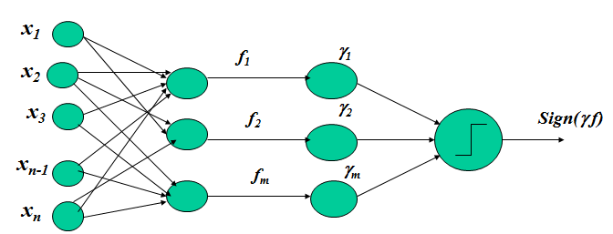
Figure 50. The general scheme of a perceptron
Let X be a set of all possible objects $\vec{x}$. Each object of the set X is referred by the teacher to one of the classes, A or B. This capability of the teacher may be represented by the certain function $F_{t}(\vec{x})$ that will assume for any object $\vec{x}$ only one of two values, “$+1$” or “$−1$”.
An ideal purpose for teaching is to get the pupil-perceptron doing what its teacher is doing, that is for any $\vec{x}$ of the set X to have the relation
$F(\vec{x})=\text{sign}(\vec{γ}, \vec{f}(\vec{x}))=F_{t}(\vec{x})\text{.}$ (13.1)
It is clear that the principle possibility of teaching is depend on the existence of such a vector $\vec{γ^{}}$ for which we could get (13.1) at every $\vec{x}∈X\text{.}$ Rosenblatt gave the following algorithm for choosing the needed vector $\vec{γ^{}}$ during the sequential shows of objects and changing the state $\vec{γ}$ of the perceptron when its response did not coincide with the teacher’s response. Namely, let the teacher’s response and the perceptron’s response be $+1$ and $−1$ respectively. So we have $\text{sign}(\vec{γ}, \vec{f}(\vec{x}))=−1$.
In order to bring the perceptron closer to the true response $+1$, it is possible to add the vector $ε\vec{f}\left(x\right)\left(ε>0\right)$ to the vector $\vec{γ}$, then the new state $\vec{γ_{n}}$ of the perceptron will be equal to
$\vec{γ_{n}}=\vec{γ}+ε\vec{f}\left(\vec{x}\right)$. (13.2)
So for the same object $\vec{x}$ we would obtain the scalar product $\left(\vec{γ_{n}}, \vec{f}\left(\vec{x}\right)\right)=\left(\vec{γ}, \vec{f}\left(\vec{x}\right)\right)+ε{\left(\vec{f}\left(\vec{x}\right)\right)}^{2}>\left(\vec{γ},\vec{f}\left(\vec{x}\right)\right)$, that is the perceptron would come closer to the right response $+1$. On the contrary let the teacher’s and the perceptron’s responses be $−1$ and $+1$ respectively.
Then the value $\left(\vec{γ},\vec{f}\left(\vec{x}\right)\right)$ should be decreased, so the new state of the perceptron should be calculated in accordance with the formula
$\vec{γ_{n}}=\vec{γ}−ε\vec{f}\left(\vec{x}\right)$. (13.3)
In this case the scalar product $\left(\vec{γ},\vec{f}\left(\vec{x}\right)\right)$ will be decreased by $−ε{\left(\vec{f}\left(\vec{x}\right)\right)}^{2}$ and the state of the perceptron will be closer to the right answer $−1$. The change of the state of the perceptron takes place only when the perceptron has performed an error.
So we have the rule:
${\vec{γ}}_{n}=\vec{γ}, \text{if}F_{t}\left(\vec{x}\right)=\text{sign}\left(\vec{γ},\vec{f}\left(\vec{x}\right)\right)$;
$${\vec{γ}}_{n}=\vec{γ}+εF_{t}\left(\vec{x}\right)\vec{f}\left(\vec{x}\right), \text{if}F_{t}\left(\vec{x}\right)=−\text{sign}\left(\vec{γ},\vec{f}\left(\vec{x}\right)\right)\text{.}$$
The both cases may be written as a single formula
${\vec{γ}}_{n}=\vec{γ}+0\text{.}5ε\left\langle F | | {}_{t}\left(\vec{x}\right)−\text{sign}\left(\vec{γ},\vec{f}\left(\vec{x}\right)\right) \right\rangle \vec{f}\left(\vec{x}\right)\text{.}$ (13.4)
The functioning of the perceptron may be described geometrically. The pattern $\vec{x}$ may be interpreted as a point in some multidimensional space $R_{n}$. In this space the function $F(\vec{x})=\text{sign}(\vec{γ}, \vec{f}(\vec{x}))$ produced by the perceptron may be represented as a fact on what side of the surface S
$(\vec{γ}, \vec{f}(\vec{x}))=0$ (13.5)
this point $\vec{x}$ is lying. If it lies on one side $(\vec{γ}, \vec{f}(\vec{x}))>0$ from this surface then the response will be equal to $+1$, if it lies on another side $(\vec{γ}, \vec{f}(\vec{x}))<0$ then the response will be equal to $−1$. The set of points X is divided into the A-class points and B-class points which must lie on the different sides of the surface (13.5). According to above said a set of points $\vec{x}$ relating to the class A may be treated as a model for the pattern A and a set of points relating to the class B may be treated as a model for the pattern B. In this case a teaching process is thought to be a constructing of the surface S, splitting the sets of points of the patterns A and B.
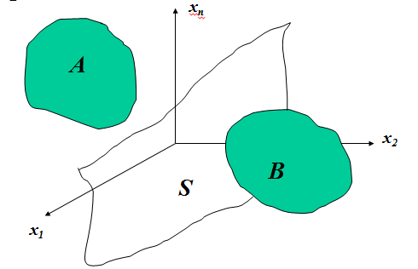

Figure 51. Geometrical illustration of two patterns to recognize
This geometrical interpretation of the visual recognition has given rise to enormous consequences. Under the patterns people now started to imply not only visual patterns but any other patterns represented numerically: handwriting, text reading and so on.
Now let us prove a possibility of teaching the perceptron with use of the teaching algorithm (13.4). We shall consider the perceptron as a dynamical system. The perceptron state vector will be interpreted as a point $\vec{γ}$ in the multidimensional phase space $Γ_{m}$ with elements $\left(γ_{1},γ_{2},\text{.}\text{.}\text{.},γ_{m}\right)$. The formula (13.4) will define the operator changing the states of this dynamical system. The perceptron states $\vec{γ^{}}$ in which the perceptron has been taught and always responds like the teacher does, will not change and will be its equilibrium states. It is easy to see, this set of equilibrium states forms a convex cone K in the space $Γ_{m}$. Indeed, the equilibrium $\vec{γ^{}}$ is defined by the requirement
$F_{t}\left(\vec{x}\right)=\text{sign}\left({\vec{γ}}^{},\vec{f}\left(\vec{x}\right)\right)$ (13.6)
for all $\vec{x}∈A∪B$. But if the requirement (13.6) is fulfilled for some vector $\vec{γ^{}}$ then it will be also fulfilled for the vector $λ\vec{γ^{}}$at any $λ>0$. Analogously, if $\vec{{γ_{1}}^{}}∈K$ and $\vec{{γ_{2}}^{}}∈K$ then $α{\vec{γ}}_{1}^{}+(1−α){\vec{γ}}_{2}^{}∈K$ for any $α∈[0,1]$. Now let us prove that if the perceptron has a cone of equilibriums containing an internal point $\vec{γ^{}}$, then it will make not more than some finite number of errors and after it the perceptron will cease making them. Let for any $\vec{x}$ the following conditions be completed
$0<r≤\left|\vec{f}\left(\vec{x}\right)\right|≤R<∞$, (13.7)
and let $\vec{γ^{}}$ be an internal point of the cone K. Then we shall obtain for some little $ρ>0$ the inequality
$\left|{\vec{γ}}^{},\vec{f}\left(\vec{x}\right)\right|≥ρ\left|{\vec{γ}}^{}\right|\left|\vec{f}\left(\vec{x}\right)\right|$, (13.8)
for all $\vec{x}∈A∪B$ independently of the length of the vector $\vec{γ^{}}$ that may be chosen arbitrarily.
Actually, if $\vec{γ^{}}$ is an internal point of the cone, then for some little $ρ>0$ and for any vector $\vec{w}$, for which $\left|\vec{w}\right|≤ρ$, we shall get the following inequalities
$\left({\vec{γ}}^{}+\vec{w}\left|{\vec{γ}}^{}\right|\right)\vec{f}\left(\vec{x}\right)>0$ for all $\vec{x}∈A$, (13.9)
$\left({\vec{γ}}^{}+\vec{w}\left|{\vec{γ}}^{}\right|\right)\vec{f}\left(\vec{x}\right)<0$ for all $\vec{x}∈B$. (13.10)
Taking $\vec{w}=−ρ\vec{f}\left(\vec{x}\right)\left|\vec{f}\left(\vec{x}\right)\right|$ in the inequality (13.9) and $\vec{w}=ρ\vec{f}\left(\vec{x}\right)\left|\vec{f}\left(\vec{x}\right)\right|$ in the inequality (13.10) we shall get the inequalities
$\left({\vec{γ}}^{},\vec{f}\left(\vec{x}\right)\right)−ρ\left|{\vec{γ}}^{}\right|\left|\vec{f}\left(\vec{x}\right)\right|>0$ for all $\vec{x}∈A$, (13.11)
$\left({\vec{γ}}^{},\vec{f}\left(\vec{x}\right)\right)+ρ\left|{\vec{γ}}^{}\right|\left|\vec{f}\left(\vec{x}\right)\right|<0$ for all $\vec{x}∈B$. (13.12)
These inequalities involve the inequality (13.8).
Let ${\vec{γ}}_{1},{\vec{γ}}_{2},\text{.}\text{.}\text{.}$ be a sequence of states of the perceptron in the course of its training by showing it some arbitrary points ${\vec{x}}_{1},{\vec{x}}_{2},\text{.}\text{.}\text{.}$ from the set $A∪B$. Let us see how the distance squared $V\left({\vec{γ}}_{i}\right)={\left({\vec{γ}}_{i}−{\vec{γ}}^{}\right)}^{2}$ of the point ${\vec{γ}}_{i}$ from the internal point $\vec{γ^{}}$ will vary with growth of the index i.
$$\begin{aligned}V\left(\vec{γ_{i+1}}\right)−V\left(\vec{γ_{i}}\right)={\left(\vec{γ_{i}}+εF_{t}\left(\vec{x}\right)\vec{f}\left(\vec{x}\right)−{\vec{γ}}^{}\right)}^{2}−{\left({\vec{γ}}_{i}−{\vec{γ}}^{}\right)}^{2}= \\ =2εF_{t}\left(\vec{x}\right)\left({\vec{γ}}_{i},\vec{f}\left(\vec{x}\right)\right)−2εF_{t}\left(\vec{x}\right)\left(γ^{},\vec{f}\left(\vec{x}\right)\right)+ε^{2}F_{t}^{2}\left(\vec{x}\right) {\vec{f }}^{2}\left(\vec{x}\right) \text{.}\end{aligned}$$
As $F_{t}\left(\vec{x}\right)\left({\vec{γ}}_{i},\vec{f}\left(\vec{x}\right)\right)<0$ and $F_{t}\left(\vec{x}\right)\left(γ^{},\vec{f}\left(\vec{x}\right)\right)>0$, then we get $V\left(\vec{γ_{i+1}}\right)−V\left(\vec{γ_{i}}\right)<−2ε\left|{\vec{γ}}^{},\vec{f}\left(\vec{x}\right)\right|+ε^{2}{\vec{f}}^{2}\left(\vec{x}\right)$. So taking into account the inequalities (13.7) and (13.8) we receive:
$$\begin{aligned}V\left(\vec{γ_{i+1}}\right)−V\left(\vec{γ_{i}}\right)<−2\text{ερ}\left|{\vec{γ}}^{}\right|\left|\vec{f}\left(\vec{x}\right)\right|+ε^{2}{\vec{f}}^{2}\left(\vec{x}\right)<<−2\text{ερ}\left|{\vec{γ}}^{}\right|r+ε^{2}R^{2}<ε\left(2ρ\left|{\vec{γ}}^{}\right|r−εR^{2}\right)\text{.}\end{aligned}$$
Taking $ε=\frac{ρr\left|{\vec{γ}}^{}\right|}{R^{2}}$ we’ll receive:
$V\left(\vec{γ_{i+1}}\right)−V\left(\vec{γ_{i}}\right)<−ρ^{2}r^{2}{\left|{\vec{γ}}^{}\right|}^{2}=−q<0$.
So with each transition from ${\vec{γ}}_{i}$ to ${\vec{γ}}_{i+1}$ the distance squared to the vector $\vec{γ^{}}$ (being always positive!) will decrease by not less than the value $q>0$, and therefore the number of such transitions must be finite.

Seminars
The seminar 1
- Draw the phase portrait of the system
a) $x^{'}=−x(x−2)(x+1)$,
b) $x^{'}=x(x+2)(x−1)$,
c) $x^{'}=(x−2)(x−1)(x+4)$.
- There are two 100 liters containers of the same shape and form. The first one is filled with the water solution consisted of 10 kg of salt. The second one is filled with pure water. We begin to add pure water (5 liters per minute) to the first container, so the solution from the first container starts to overflow into the second one. The solution from the second container overflows with the same speed (5 liters per minute). When will the amount of salt in the second container be at its maximum?
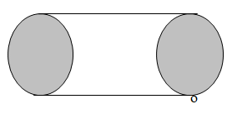
The seminar 2
Problem 1. There is a cylindrical container filled with water. The dimensions of the container are: the diameter is equal to 2.25 m and the eight is equal to 2.25 m. The container has a hole $σ$= 4 cm² in the bottom. It’s necessary to empty the container as fast as possible. What kind of the position of the container you choose: vertical or horizontal?
Problem 2. There is a cylindrical container filled with water. The dimensions of the container are: the diameter is equal to 2 m and the eight is equal to 1 m. The container has two holes of the same diameter 4 cm. One hole is in the bottom and the other one is in the side wall at the eight 0.5 m. Find the time of emptying of this container.
The seminar 3
Problem1. There is a cylindrical container filled with water. The dimensions of the container are: the diameter is equal to 2 m and the eight is equal to 1m. The container has two holes of the same diameter 4 cm. One hole is in the bottom and the other one is in the side wall at the eight 0.5 m. Let $Q$ be the intensity of a constant inflow to the container. What are conditions the container would not be overfilled?
Problem 2. Water is flowing out the first container with dimensions $S×H$ through the hole of sectional area $σ$ to the second one having the same dimensions including the hole. When will the quantity of water in the second container be at its maximum, if at the initial moment the first container is filled with water and the second container is empty.
The seminar 4
Problem1. There is a container filled with water. The container has the shape of a cone (see figure 56). Dimensions of the container are: the diameter D is equal to 2 m and the eight H is equal to 1m. The container has A hole of the diameter 4 cm. Find the time of emptying of this container.
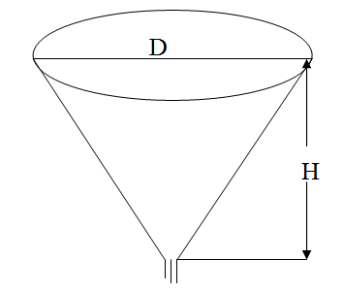
Figure 56. Process of emptying of the container

The seminar 5
Problem 1. Two bodies of the mass m clamped by a spring with an elasticity coefficient k may move along a horizontal line without any friction. Construct mathematical model of their movements, find the solutions and give their physical interpretation.
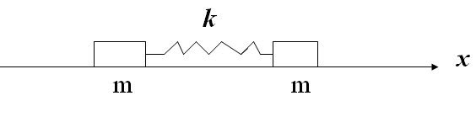
Figure 57. Movement of two bodies clamped by a spring
Problem 2. A material point of the mass m is moving without any friction along a curve y = f(x) in a vertical plane. Construct mathematical model of its movement, investigate its phase space and give a physical interpretation.
- $y=x^{4}−2x^{2}+2$,
- $y=−x^{4}+2x^{2}−2$,
- $y=x^{3}−3x+1$.
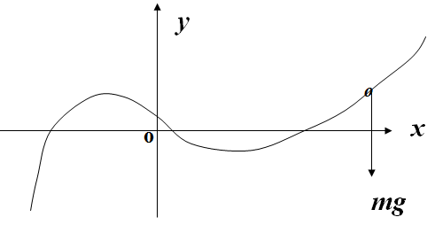
Figure 58. Movement of a material point along a curve
The seminar 6
Problem 1. Two bodies of the masses m₁ and m₂ clamped by a spring with an elasticity coefficient k may move along a horizontal line with a friction. The mass m₂ is affected by a harmonic force ${\text{Fe}}^{iνt}$. Construct a mathematical model of their movements, find the forced oscillations of the mass m₁ and draw its amplitude-phase frequency characteristic $w=K(iν)$.
Problem 2. There is an electrical circuit, serving as an element of a filter
( see the figures 59 and 60). The voltage at its input is ${\text{Ve}}^{iνt}$. Find the voltage V at its output, draw the APFC, and the amplitude characteristic.

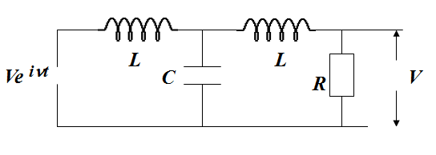
Figure 59. Element of a slow-frequency filter
Why this element may be a part of a slow-frequency filter? (C = 0.25, L = 1, R = 3).
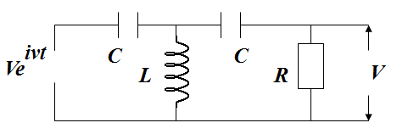
Figure 60. Element of a high-frequency filter
Why this element may be a part of a high-frequency filter? (C = 0.5, L = 2, R = 2).
The seminar 7
Problem 1. Construct and analyze a model of the kind “predator-prey” provided that the population of preys has a shelter of the volume D.
Problem 2. Analyze a model for two competing populations provided that one of the coefficients $a_{\text{12}},a_{\text{13}}$ be equal to zero.
The seminar 8
Problem 1. A cosmic apparatus with initial height H and initial speed V is moving down to a planet under its gravitation. We have to make a soft landing. To realize it we may use a missile jet engine at some height H₁. Construct and investigate the mathematical models for three cases:
1) $H\text{<<}R$,
2) H is compared to R (R is the radius of the planet).
3) Initial height H is not large, there is an atmosphere.
The seminar 9
Problem 1. Construct and investigate an automata model of rational behaviour of a rat with a depth of the memory equal to three.
Problem 2. Investigate the problem of pursuing when P will be an object running out and R will be an object pursuing. Select a corresponding strategy for P.
The seminar 10
Problem 1. Consider a discrete markovian process with incomes for an artisan producing some handicraft wares and having the purpose to sell them. The result is supposed to be different: the state 1 means the artisan sold all his handicraft wares and has a good income; the state 2 means the artisan sold only half of his handicraft wares and has an income; the state 3 means the artisan did not sell anything and has no an income. Find the solution $p_{i}(n), i=1, 2, 3,$ of the markovian process and the solution $V_{i}(n), i=1, 2, 3,$ of the equation for the incomes. The matrices of the conditional probabilities and the corresponding incomes are represented below.
$$P=\begin{matrix}0\text{.}5 & 0\text{.}3 & 0\text{.}2 \\ 0\text{.}4 & 0\text{.}3 & 0\text{.}3 \\ 0\text{.}2 & 0\text{.}3 & 0\text{.}5\end{matrix} D=\begin{matrix}9 & 7 & 3 \\ 6 & 2 & 0 \\ 3 & 0 & −6\end{matrix}$$
The seminar 11
Problem 1. Using the method of R. Howard find the optimal strategy for the object P in the problem of pursuing (theme 9) if it has the purpose to stay far away from the object R.
Problem 2. A farmer has leased a plot of land in order to producing vegetables. The farmer may use each year one of the following strategies: 1) invest 2 units of money to keep up the fertility of the soil; 2) not invest any money. Four levels of the fertility are supposed: excellent, good, satisfactory and bad. Using the first strategy the farmer will receive the incomes 9, 7, 4, 2 provided the soil be excellent, good, satisfactory or bad respectively. Using the second strategy the farmer will receive the incomes 11, 9, 6, 4 provided the soil be excellent, good, satisfactory or bad respectively. The initial fertility of the soil leased by the farmer was good.
The results of his activity may be stochastic due an influence of weather. The matrices of conditional probabilities $p_{\text{ij}}, i,j=1, 4$ are represented below for both of the two strategies.
1) Find an optimal strategy for the period within 3 years of the date of the contract.
2) Using method of Howard find an optimal strategy for an infinite period.
$$P^{1}=\begin{matrix}0\text{.}5 & 0\text{.}3 & 0\text{.}2 & 0\text{.}0 \\ 0\text{.}4 & 0\text{.}4 & 0\text{.}2 & 0\text{.}0 \\ 0\text{.}3 & 0\text{.}4 & 0\text{.}2 & 0\text{.}1 \\ 0\text{.}1 & 0\text{.}3 & 0\text{.}4 & 0\text{.}2\end{matrix} P^{2}=\begin{matrix}0\text{.}3 & 0\text{.}5 & 0\text{.}2 & 0\text{.}0 \\ 0\text{.}1 & 0\text{.}5 & 0\text{.}3 & 0\text{.}1 \\ 0\text{.}0 & 0\text{.}2 & 0\text{.}5 & 0\text{.}3 \\ 0\text{.}0 & 0\text{.}0 & 0\text{.}3 & 0\text{.}7\end{matrix}$$
The seminar 12
Let us consider the problem 2 (theme 12): find a vector $X^{0}∈H$
$$H=\left\{X∈Z_{n}:A_{k}≤\sum_{i=1}^{i=k}{x_{i}≤B_{k}, k=\vec{1, n−1};} \sum_{i=1}^{i=n}{x_{i}=P}\right\}$$
such that $F(X^{0})≤F(x)$ for every $X∈H$. The parameters $A_{k}<B_{k}$ are supposed to be whole numbers.
Exercise 1. Prove the theorem: vector $X^{0}∈H$ is optimal for the problem 2 if and only if every two its components $x_{k}^{0}$ and $x_{j}^{0}(k>j)$ are satisfying one of the following conditions :
a) $x_{k}^{0}−x_{j}^{0}∈\left\{−1, 0, 1\right\};$
b) $x_{k}^{0}−x_{j}^{0}>1;$ then there exists a number $m∈\left\{j, j+1,…, k−1\right\}$ such that $\sum_{i=1}^{i=m}{x_{i}=B_{m}}$;
c) $x_{k}−x_{j}<−1,$, then there exists a number $m∈\left\{j, j+1,…, k−1\right\}$ such that $\sum_{i=1}^{i=m}{x_{i}=A_{m}}$.
Exercise 2. Create an iterative algorithm based on the above theorem. Apply this algorithm to find an optimal vector for the problem 2 if P = 60, n =12 and the limits of the set H are represented below:
j: | 1 | 2 | 3 | 4 | 5 | 6 | 7 | 8 | 9 | 10 | 11 | 12
$$A_{j}$$ | 1 | 3 | 5 | 8 | 10 | 16 | 22 | 27 | 39 | 45 | 51 | 58
$$B_{j}$$ | 6 | 8 | 10 | 13 | 15 | 21 | 27 | 32 | 44 | 50 | 58 | 63

The seminar 13
Problem 1. It’s necessary to find a vector $X^{0}$ in the set
$$H=\left\{X∈Z_{n}:A_{k}≤\sum_{i=1}^{i=k}{x_{i}≤B_{k}, k=\vec{1,n−1};\sum_{i=1}^{i=n}{x_{i}=P}}\right\}$$
such that $Q(X^{0})=\text{min}Q(X)$ for every $X∈H$, where
$$Q\left(X\right)=\sum_{i=0}^{i=n}{{\left(x_{i+1}−x_{i}\right)}^{2}},x_{0}=x_{n+1}=\frac{P}{n}\text{.}$$
Prove the theorem: if a vector $X^{0}∈H$ is optimal for the problem 1 then every four its components are satisfying one of the following conditions:
a) $−x_{k−1}^{0}+{3x}_{k}^{0}−{3x}_{k+1}^{0}+x_{k+2}^{0}∈\left\{−3,−2,−1,0,1,2,3\right\};$
b) $−x_{k−1}^{0}+{3x}_{k}^{0}−{3x}_{k+1}^{0}+x_{k+2}^{0}<−3$ and $\sum_{i=1}^{i=k}{x_{i}^{0}=B_{k}}$;
c) $−x_{k−1}^{0}+{3x}_{k}^{0}−{3x}_{k+1}^{0}+x_{k+2}^{0}>3$ and $\sum_{i=1}^{i=k}{x_{i}^{0}=A_{k}\text{.}}$
Problem 2. Create an iterative algorithm based on the above theorem. Apply this algorithm to find an optimal vector for the problem 1 if $P=\text{60}$ and the limits of the set H are represented below:
K: | 1 | 2 | 3 | 4 | 5 | 6 | 7 | 8 | 9 | 10 | 11 | 12
$$A_{k}$$ | 1 | 3 | 5 | 8 | 10 | 16 | 22 | 27 | 39 | 45 | 51 | 58
$$B_{k}$$ | 6 | 8 | 10 | 13 | 15 | 21 | 27 | 32 | 44 | 50 | 58 | 63

References

1. Neimark Ju.I. Mathematical models in Natural Science and Engineering. – Berlin-Heidelberg: Springer Verlag, 2003. – 570 p.
2. Howard R.A. Dynamic programming and Markov processes. Cambridge: Technology Press of Massachusetts Institute of Technology, 1960. – 136 p.
3. Беллман Р. Динамическое программирование. – М.,1960.
4. Kuhn H.W., Tucker A.W. Nonlinear programming. – Berkeley: University of California Press, 1951. – pp. 481-492.
5. Савельев В.П. Математические модели ритмичного производства: Учебно-методическое пособие. – Н.Новгород: Изд-во ННГУ, 2009. – 35с.

Владимир Петрович Савельев
Артем Виленович Островский
Галина Владимировна Кузенкова

КОНЦЕПЦИИ СОВРЕМЕННОГО ЕСТЕСТВОЗНАНИЯ

Учебно-методическое пособие

Федеральное государственное автономное образовательное учреждение высшего образования «Национальный исследовательский Нижегородский государственный университет им. Н.И. Лобачевского».

603950, Нижний Новгород, пр. Гагарина, 23.

